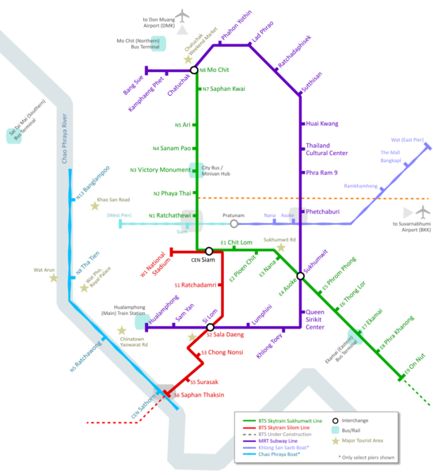

The cheapest and most colorful way of reaching Ayutthaya is by train. All north and north-east line trains depart from Bangkok's Hualamphong Train Station and stop in Ayutthaya, a trip of about 1.5 hours. Second class (non-aircon) costs 35 baht (seats can be booked in advance), while third class is just 20 baht (no reservations). See Thailand "State Railway" for schedule and cost. 1st Class = 66 baht. You can check all the fares in http://www.railway.co.th/English/FareRate.asp (7:00,8:30,9:25,10:50,14:30,18:00)
Ayutthaya's train station is to the east of the central island. The easiest way to get to central Naresuan Road is to walk straight ahead from the station and take the cross-river ferry for 3 baht.

kok toy train+bus...
Using the comfortable overnight sleeper from Bangkok, the train+bus to Krabi takes no more time out of your holiday than flying, but is a lot more interesting, cheaper, and far more environmentally friendly. Take a comfortable train from Bangkok to Surat Thani - see the see the train times above. Train 85 leaving central Bangkok at 19:30 is a good choice. Then take a bus from Surat Thani station to Krabi. You're likely to find a number of buses to Krabi waiting at Surat Thani station after the arrival of your train. The bus fare is about 150 baht (£2 or $4), the journey time from Surat Thani to Krabi is about 2 hours. You can buy combined train+bus tickets from Bangkok to Krabi sold by the State Railways of Thailand or online from www.traveller2000.com.

Bangkok ► Hua Hin ► Surat Thani ► Hat Yai ► Sungai Kolok
Train number: | 43 * | 261 | 171 | 35 * | 37 * | 169 | 83 * | 173 | 167 | 85 * | 41
Classes: | DRC | 3 | s,2,3 | 1,S,2 | 1,S,2,3 | s,2,3 | 1,S,2,3 | s,2,3 | s,2,3 | 1,S,2,3 | DRC
Depart Bangkok (Hualamphong): | 08:05 | 09:20 | 13:00 | 14:45 | 15:10 | 15:35 | 17:05 | 17:35 | 18:20 | 19:30 | 22:50
Depart Nakhon Pathom: | 09:17 | 10:37 | 14:42 | 16:04 | 16:39 | 17:17 | 18:29 | 19:09 | 19:51 | 20:54 | 00:03
Arrive/depart Hua Hin: | 11:11 | 13:00 | 17:10 | 18:11 | 19:08 | 20:11 | 20:43 | 21:37 | 22:02 | 23:19 | 02:04
Arrive Chumphon (for ferry to Koh Tao) | 14:19 | - | 21:01 | 21:47 | 23:22 | 00:35 | 01:20 | 02:19 | 02:56 | 03:44 | 05:42
Arrive Surat Thani (for Ko Samui & Krabi): | 16:30 | - | 00:09 | 00:46 | 01:53 | 03:02 | 04:02 | 05:09 | 05:38 | 06:27 | 08:11
Arrive Trang: | - | - | | | | | | | | | 07:55 | - | 10:20 | - | |
Arrive Hat Yai: | - | - | 05:36 | 06:18 | 07:18 | 09:07 | - | - | - | - | 12:27
Arrive Sungai Kolok: | - | - | 10:45 | - | 11:25 | - | - | - | - | - | -
Classes:
1 = 1st class sleeper. S = 2nd class sleeper (air-con). s = 2nd class sleeper (non-air-con). 2 = 2nd class seats.
3 = 3rd class seats. DRC = Diesel Railcar express with 2nd class air-conditioned seats, meals included.
* Recommended trains - express railcar by day, the best air-con sleepers overnight.

Sungai Kolok ► Hat Yai ► Surat Thani ► Hua Hin ► Bangkok
Train number: | 40 * | 174 | 86 * | 42 | 168 | 170 | 84 * | 172 | 38 * | 36 * | 262
Classes: | DRC | s,2,3 | 1,S,2,3 | DRC | s,2,3 | s,2,3 | 1,S,2,3 | s,2,3 | 1,S,2 | 1,S,2 | 3
Depart Sungai Kolok: | - | - | - | - | - | - | - | 11:30 | 14:20 | - | -
Depart Hat Yai: | - | - | - | 16:16 | - | 14:18 | - | 15:26 | 18:05 | 18:55 | -
Depart Trang: | - | - | - | | | 13:25 | | | 17:20 | | | | | | | -
Depart Surat Thani: | 10:40 | 16:46 | 18:22 | 20:25 | 17:42 | 19:45 | 20:47 | 21:07 | 23:00 | 23:24 | -
Depart Chumphon: | 12:46 | 19:24 | 20:44 | 22:31 | 20:32 | 22:20 | 23:24 | 23:53 | 01:36 | 02:23 | -
Arrive/depart Hua Hin | 16:01 | 00:13 | 01:19 | 01:39 | 00:49 | 02:58 | 03:38 | 04:07 | 05:34 | 06:07 | 14:10
Arrive Nakhon Pathom: | 18:15 | 03:04 | 03:59 | 03:48 | 03:30 | 05:43 | 06:15 | 06:34 | 08:05 | 08:50 | 16:59
Arrive Bangkok (Hualamphong): | 19:35 | 04:45 | 05:35 | 05:15 | 05:05 | 07:40 | 08:00 | 08:10 | 09:40 | 10:50 | 18:45
How to buy tickets Map of train routes in Southeast Asia Check seat/berth availability

Fares
From Bangkok to: |  | 1st class sleeper  a/c express train | 2nd class sleeper  a/c express train | 2nd class seat  a/c fast railcar | 2nd class seat  ordinary train | 3rd class seat  ordinary train
Hua Hin | 229 km | - | - | 382 (£5, $8) | 292 (£4, $7) | 234 (£3, $5)
Chumphon | 485 km | 1,134 (£16, $28) | 770 (£11, $18) | 480 (£7, $12) | 380 (£5, $8) | 272 (£4, $7)
Surat Thani | 651 km | 1,279 (£18, $31) | 848 (£12, $20) | 578 (£8, $14) | 438 (£6, $10) | 297 (£4, $6)
Hat Yai | 945 km | 1,494 (£21, $37) | 945 (£13, $23) | 675 (£9, $16) | 535 (£7, $12) | 339 (£4, $7)
Children aged 0 to 3 and less than 100cm in height travel free, children aged 4 to 11 and under 150cm travel at half fare, children 12 years old and upwards (or over 150cm high) pay full fare.
The 2nd class sleeper fares shown here are for a lower bunk, a narrower upper bunk is 50-100 baht less. Non-air-con sleepers (available on a few trains) cost 160-200 baht less than the air-con variety. You can check fares at www.railway.co.th (but do this by selecting 'timetables' as the fares shown at the bottom of each timetable page include the air-conditioning supplement, sleeper & special express supplements. If you select the 'fares' option, the fares shown don't include those supplements.
Journey time is approx 1.5 hours and ticket price 350 Baht/person (one way). Boats depart from Krabi Passenger Pier on Tharua Rd, approximately 4km out of the town centre. Boats from Phi Phi depart from the pier on Ton Sai Bay. (krabi to phi = 10:00 e 15:00 // phi to krabi = 9:00 e 14:00)
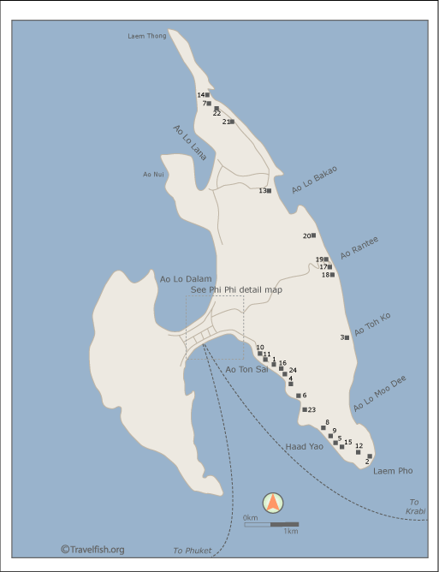
Phi Phi Andaman Resort – 12.50 euros
Phi Phi Andaman Resort, 1 Moo 7, Ao-Nang, Muang, Koh Phi Phi, Krabi, 81000, Thailand
1: Andaman Beach Resort 2: Ao Poh Resort 3: Ao Toh Ko Bungalows 4: Arayaburi Bay View Resort
5: Long Beach Bungalows 6: Maphrao Resort 7: P.P. Erawan Palms Dive Resort 8: Paradise Pearl Bungalow
9: Paradise Resort 10: Phi Phi Andaman Bungalows 11: Phi Phi Andaman Resort 12: Phi Phi Hil
13: Phi Phi Island Village 14: Phi Phi Natural Resort 15: Phi Phi The Beach Resort 16: Phi Phi Villa Resort
17: Rantee Beach P.P. Island 18: Rantee Hut 19: Rantee Yaa 20: Relax Beach Resort 21: The Holiday Inn
22: The Zeavola 23: Viking Place Resort 24: Chao Ko Phi Phi Lodge
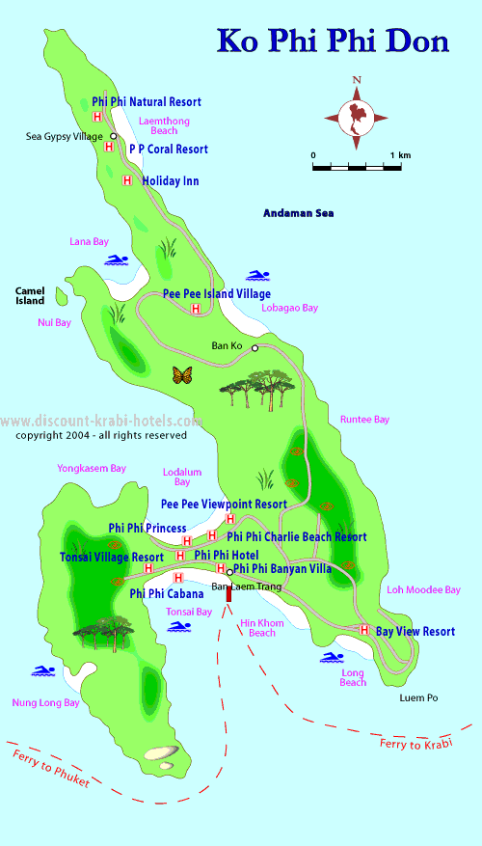Aranyaprathet, 255 km from Bangkok, is just 15 km from the Cambodian border post at Poiphet from where buses run to Siem Reap and Battambang for the Cambodian train to Phnom Penh. See the Cambodia page for more information on Cambodian trains and the bus onwards from Phnom Penh to Saigon in Vietnam.
Trains 275-280 have 3rd class seats only, but Thai 3rd class is quite clean and comfortable, and a pleasant way to travel. Pictured right: A 3rd class car with wooden seats, as used on the Bangkok-Aranyaprathet trains. Photo courtesy of Steve252
Bangkok ► Aranyaprathet |  |  |  | Aranyaprathet ► Bangkok
Train number: | 275 | 279 |  | Train number: | 280 | 276
Class: | 3 | 3 |  | Class: | 3 | 3
Bangkok (Hualamphong) depart: | 05:55 | 13:05 |  | Aranyaprathet depart: | 06:40 | 13:55
Aranyaprathet arrive: | 11:35 | 17:35 |  | Bangkok (Hualamphong) arrive: | 12:05 | 19:55

Fares:
Bangkok to Aranyaprathet (255 km): 48 baht (£0.70 or $1)
No reservation required - just turn up, buy a ticket and hop on.

Train
There are two 3rd class only trains a day from Bangkok to Aranyaprathet. The morning train leaves at 05:55, the afternoon one at 13:05. The trip takes around five and a half hours. If you want to get to Siem Reap on the same day, you must catch the morning train. With the afternoon train you'll need to overnight in Aranyaprathet or Poipet. The train is slow but scenic -- if you have time on your hands it is worth doing at least once.
At Aranyaprathet
Once you're at Aranyaprathet you need to take a tuk tuk or motorbike to Rongklua border market which is 7km away. The ride should cost 80-100B depending on the number of passengers. Under no circumstances allow a tout into the tuk tuk with you.
At Rongklua market
The tuk tuk will drop you off at the border market where you need to clear both Thai and Cambodian immigration and customs. As you walk towards the border crossing you will be approached by touts -- ignore them -- do not even acknowledge their existence.
Immigration and customs
The Poipet border crossing is open from 07:30-20:00 daily. Clearing Thai immigration and customs is straightforward. Depending on your nationality, you will need a visa to Cambodia to be able to enter. The visa costs US$20 and you'll need to supply one passport photo. You are well advised to have enough crisp US notes to pay for this as if you have to pay in Baht you'll be given an awful exchange rate.
At Poipet
Once you've been stamped into Cambodia, take the government shuttle bus from the border to the transport depot. From there you have three choices -- share-taxi, government bus or pick-up -- we recommend taking a taxi.
Leaving Poipet
One of the best things about Poipet is leaving it. A taxi to Siem Reap will cost US$45, so try to hook up with other backpackers to split the fare. The government bus costs $10. A ride in a pick-up will cost you 30B in the back or 100B for two seats in the cab -- note this is only to Sisophon, from where you'll need to organise another ride on to Siem Reap. If you're going by pick-up we'd suggest splurging and buying two seats in the cab -- it's a dusty, uncomfortable ride. When shopping around for a pick-up be sure to choose one that is almost full. Some guesthouses in Siem Reap can supply a pick-up service from the border -- check with your guesthouse to see if this is possible.
Poipet to Siem Reap
This road has gained near legendary status for its poor condition and while things have improved considerably, it still isn't one of the better roads in Cambodia -- the quality of the surface ranges from totally unsealed to pretty good. Overall trip time by taxi is three to four hours, by bus five to seven. In wet season the trip can take longer. The best place to get up-to-date information on this road is from the Tales of Asia website, which has a page dedicated solely to the conditions of the Poipet to Siem Reap road.
Scam buses
At both Khao San Road and Siem Reap you'll see minibuses offered for next to nothing for the Bangkok to Siem Reap run. These are invariably scams that in some cases have taken in excess of 20 hours to deliver the passengers. Do NOT use these services.

