Playlist (7 talks): MOOCs 101

Given that it’s the internet age and all, why should classrooms look exactly the way they have for centuries? Here, TED speakers on what can happen when we bring education online … and open it up to anyone.

* [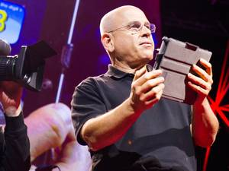16:25](https://www.ted.com/talks/shimon_schocken_the_self_organizing_computer_course)

[Shimon Schocken](https://www.ted.com/speakers/shimon_schocken) [The self-organizing computer course](https://www.ted.com/talks/shimon_schocken_the_self_organizing_computer_course)

Shimon Schocken and Noam Nisan developed a curriculum for their students to build a computer, piece by piece. When they put the course online — giving away the tools, simulators, chip specifications and other building blocks — they were surprised that thousands jumped at the opportunity to learn, working independently as well as organizing their own classes in the first Massive Open Online Course (MOOC). A call to forget about grades and tap into the self-motivation to learn.

[Watch later](https://www.ted.com/session/new) · [90 comments](https://www.ted.com/talks/shimon_schocken_the_self_organizing_computer_course)

* [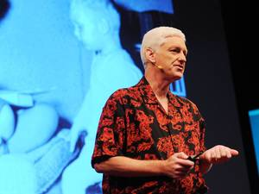6:11](https://www.ted.com/talks/peter_norvig_the_100_000_student_classroom)

[Peter Norvig](https://www.ted.com/speakers/peter_norvig) [The 100,000-student classroom](https://www.ted.com/talks/peter_norvig_the_100_000_student_classroom)

In the fall of 2011 Peter Norvig taught a class with Sebastian Thrun on artificial intelligence at Stanford attended by 175 students in situ — and over 100,000 via an interactive webcast. He shares what he learned about teaching to a global classroom.

[Watch later](https://www.ted.com/session/new) · [94 comments](https://www.ted.com/talks/peter_norvig_the_100_000_student_classroom)

* 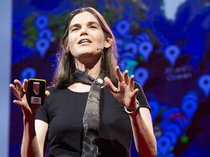[20:40](https://www.ted.com/talks/daphne_koller_what_we_re_learning_from_online_education)

[Daphne Koller](https://www.ted.com/speakers/daphne_koller) [What we're learning from online education](https://www.ted.com/talks/daphne_koller_what_we_re_learning_from_online_education)

Daphne Koller is enticing top universities to put their most intriguing courses online for free — not just as a service, but as a way to research how people learn. With Coursera (cofounded by Andrew Ng), each keystroke, quiz, peer-to-peer discussion and self-graded assignment builds an unprecedented pool of data on how knowledge is processed.

[Watch later](https://www.ted.com/session/new) · [444 comments](https://www.ted.com/talks/daphne_koller_what_we_re_learning_from_online_education)

* [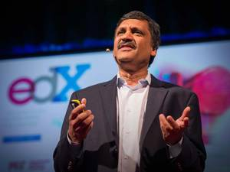15:19](https://www.ted.com/talks/anant_agarwal_why_massively_open_online_courses_still_matter)

[Anant Agarwal](https://www.ted.com/speakers/anant_agarwal) [Why massive open online courses (still) matter](https://www.ted.com/talks/anant_agarwal_why_massively_open_online_courses_still_matter)

2013 was a year of hype for MOOCs (massive open online courses). Great big numbers and great big hopes were followed by some disappointing first results. But the head of edX, Anant Agarwal, makes the case that MOOCs still matter — as a way to share high-level learning widely and supplement (but perhaps not replace) traditional classrooms. Agarwal shares his vision of blended learning, where teachers create the ideal learning experience for 21st century students.

[Watch later](https://www.ted.com/session/new) · [167 comments](https://www.ted.com/talks/anant_agarwal_why_massively_open_online_courses_still_matter)

* [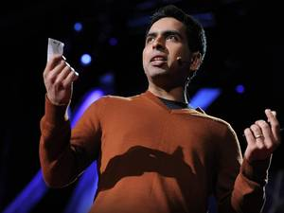20:27](https://www.ted.com/talks/salman_khan_let_s_use_video_to_reinvent_education)

[Salman Khan](https://www.ted.com/speakers/salman_khan) [Let's use video to reinvent education](https://www.ted.com/talks/salman_khan_let_s_use_video_to_reinvent_education)

Salman Khan talks about how and why he created the remarkable Khan Academy, a carefully structured series of educational videos offering complete curricula in math and, now, other subjects. He shows the power of interactive exercises, and calls for teachers to consider flipping the traditional classroom script — give students video lectures to watch at home, and do "homework" in the classroom with the teacher available to help.

[Watch later](https://www.ted.com/session/new) · [498 comments](https://www.ted.com/talks/salman_khan_let_s_use_video_to_reinvent_education)

* [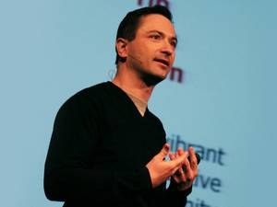18:34](https://www.ted.com/talks/richard_baraniuk_on_open_source_learning)

[Richard Baraniuk](https://www.ted.com/speakers/richard_baraniuk) [The birth of the open-source learning revolution](https://www.ted.com/talks/richard_baraniuk_on_open_source_learning)

In 2006, open-learning visionary Richard Baraniuk explains the vision behind Connexions (now called OpenStax), an open-source, online education system. It cuts out the textbook, allowing teachers to share and modify course materials freely, anywhere in the world.

[Watch later](https://www.ted.com/session/new) · [101 comments](https://www.ted.com/talks/richard_baraniuk_on_open_source_learning)

* [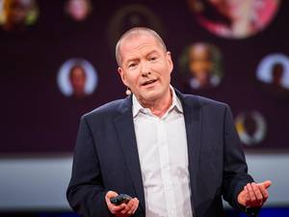10:48](https://www.ted.com/talks/shai_reshef_a_tuition_free_college_degree)

[Shai Reshef](https://www.ted.com/speakers/shai_reshef) [An ultra-low-cost college degree](https://www.ted.com/talks/shai_reshef_a_tuition_free_college_degree)

At the online University of the People, anyone with a high school diploma can take classes toward a degree in business administration or computer science — without standard tuition fees (though exams cost money). Founder Shai Reshef hopes that higher education is changing "from being a privilege for the few to a basic right, affordable and accessible for all."

[Watch later](https://www.ted.com/session/new) · [107 comments](https://www.ted.com/talks/shai_reshef_a_tuition_free_college_degree)