#### [11 must-see TED Talks](https://www.ted.com/playlists/77/11_must_see_ted_talks)

**Playlist (11 talks): 11 must-see TED Talks**

What is TED? This primer of 11 classic TED Talks show you the wide range of topics covered -- and introduce you to beloved speakers like Amy Cuddy, Brené Brown, Sir Ken Robinson and Chimamanda Adichie. Find your next favorite talk

* [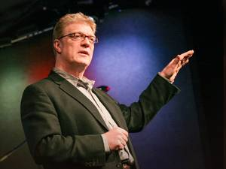19:24](https://www.ted.com/talks/ken_robinson_says_schools_kill_creativity)

[Ken Robinson](https://www.ted.com/speakers/sir_ken_robinson) [How schools kill creativity](https://www.ted.com/talks/ken_robinson_says_schools_kill_creativity)

Sir Ken Robinson makes an entertaining and profoundly moving case for creating an education system that nurtures (rather than undermines) creativity.

[Watch later](https://www.ted.com/session/new) · [3782 comments](https://www.ted.com/talks/ken_robinson_says_schools_kill_creativity)

* [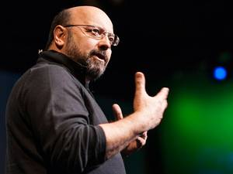5:27](https://www.ted.com/talks/david_gallo_shows_underwater_astonishments)

[David Gallo](https://www.ted.com/speakers/david_gallo) [Underwater astonishments](https://www.ted.com/talks/david_gallo_shows_underwater_astonishments)

David Gallo shows jaw-dropping footage of amazing sea creatures, including a color-shifting cuttlefish, a perfectly camouflaged octopus, and a Times Square's worth of neon light displays from fish who live in the blackest depths of the ocean. This short talk celebrates the pioneering work of ocean explorers like Edith Widder and Roger Hanlon.

[Watch later](https://www.ted.com/session/new) · [492 comments](https://www.ted.com/talks/david_gallo_shows_underwater_astonishments)

* 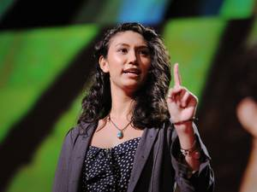[18:25](https://www.ted.com/talks/sarah_kay_if_i_should_have_a_daughter)

[Sarah Kay](https://www.ted.com/speakers/sarah_kay) [If I should have a daughter ...](https://www.ted.com/talks/sarah_kay_if_i_should_have_a_daughter)

"If I should have a daughter, instead of Mom, she's gonna call me Point B ... " began spoken word poet Sarah Kay, in a talk that inspired two standing ovations at TED2011. She tells the story of her metamorphosis — from a wide-eyed teenager soaking in verse at New York's Bowery Poetry Club to a teacher connecting kids with the power of self-expression through Project V.O.I.C.E. — and gives two breathtaking performances of "B" and "Hiroshima."

[Watch later](https://www.ted.com/session/new) · [609 comments](https://www.ted.com/talks/sarah_kay_if_i_should_have_a_daughter)

* 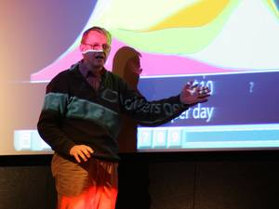[19:50](https://www.ted.com/talks/hans_rosling_shows_the_best_stats_you_ve_ever_seen)

[Hans Rosling](https://www.ted.com/speakers/hans_rosling) [The best stats you've ever seen](https://www.ted.com/talks/hans_rosling_shows_the_best_stats_you_ve_ever_seen)

You've never seen data presented like this. With the drama and urgency of a sportscaster, statistics guru Hans Rosling debunks myths about the so-called "developing world."

[Watch later](https://www.ted.com/session/new) · [495 comments](https://www.ted.com/talks/hans_rosling_shows_the_best_stats_you_ve_ever_seen)

* 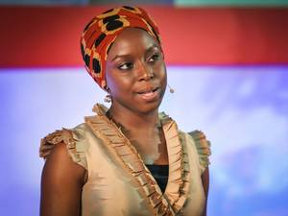[18:49](https://www.ted.com/talks/chimamanda_adichie_the_danger_of_a_single_story)

[Chimamanda Ngozi Adichie](https://www.ted.com/speakers/chimamanda_ngozi_adichie) [The danger of a single story](https://www.ted.com/talks/chimamanda_adichie_the_danger_of_a_single_story)

Our lives, our cultures, are composed of many overlapping stories. Novelist Chimamanda Adichie tells the story of how she found her authentic cultural voice — and warns that if we hear only a single story about another person or country, we risk a critical misunderstanding.

[Watch later](https://www.ted.com/session/new) · [965 comments](https://www.ted.com/talks/chimamanda_adichie_the_danger_of_a_single_story)

* [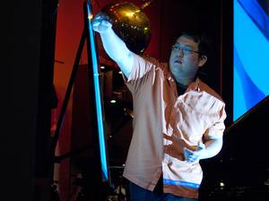5:40](https://www.ted.com/talks/johnny_lee_demos_wii_remote_hacks)

[Johnny Lee](https://www.ted.com/speakers/johnny_lee) [Free or cheap Wii Remote hacks](https://www.ted.com/talks/johnny_lee_demos_wii_remote_hacks)

Building sophisticated educational tools out of cheap parts, Johnny Lee demos his cool Wii Remote hacks, which turn the $40 video game controller into a digital whiteboard, a touchscreen and a head-mounted 3-D viewer.

[Watch later](https://www.ted.com/session/new) · [255 comments](https://www.ted.com/talks/johnny_lee_demos_wii_remote_hacks)

* [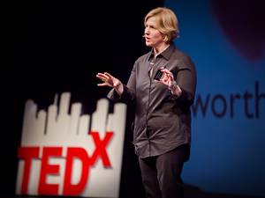20:19](https://www.ted.com/talks/brene_brown_on_vulnerability)

[Brené Brown](https://www.ted.com/speakers/brene_brown) [The power of vulnerability](https://www.ted.com/talks/brene_brown_on_vulnerability)

Brené Brown studies human connection — our ability to empathize, belong, love. In a poignant, funny talk, she shares a deep insight from her research, one that sent her on a personal quest to know herself as well as to understand humanity. A talk to share.

[Watch later](https://www.ted.com/session/new) · [1621 comments](https://www.ted.com/talks/brene_brown_on_vulnerability)

* [23:41](https://www.ted.com/talks/bryan_stevenson_we_need_to_talk_about_an_injustice)

[Bryan Stevenson](https://www.ted.com/speakers/bryan_stevenson) [We need to talk about an injustice](https://www.ted.com/talks/bryan_stevenson_we_need_to_talk_about_an_injustice)

In an engaging and personal talk — with cameo appearances from his grandmother and Rosa Parks — human rights lawyer Bryan Stevenson shares some hard truths about America's justice system, starting with a massive imbalance along racial lines: a third of the country's black male population has been incarcerated at some point in their lives. These issues, which are wrapped up in America's unexamined history, are rarely talked about with this level of candor, insight and persuasiveness.

[Watch later](https://www.ted.com/session/new) · [505 comments](https://www.ted.com/talks/bryan_stevenson_we_need_to_talk_about_an_injustice)

* [18:14](https://www.ted.com/talks/bjarke_ingels_3_warp_speed_architecture_tales)

[Bjarke Ingels](https://www.ted.com/speakers/bjarke_ingels) [3 warp-speed architecture tales](https://www.ted.com/talks/bjarke_ingels_3_warp_speed_architecture_tales)

Danish architect Bjarke Ingels rockets through photo/video-mingled stories of his eco-flashy designs. His buildings not only look like nature — they act like nature: blocking the wind, collecting solar energy — and creating stunning views.

[Watch later](https://www.ted.com/session/new) · [208 comments](https://www.ted.com/talks/bjarke_ingels_3_warp_speed_architecture_tales)

* [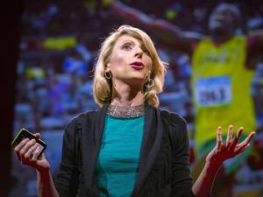21:02](https://www.ted.com/talks/amy_cuddy_your_body_language_shapes_who_you_are)

[Amy Cuddy](https://www.ted.com/speakers/amy_cuddy) [Your body language shapes who you are](https://www.ted.com/talks/amy_cuddy_your_body_language_shapes_who_you_are)

Body language affects how others see us, but it may also change how we see ourselves. Social psychologist Amy Cuddy shows how “power posing” — standing in a posture of confidence, even when we don’t feel confident — can affect testosterone and cortisol levels in the brain, and might even have an impact on our chances for success.

[Watch later](https://www.ted.com/session/new) · [1689 comments](https://www.ted.com/talks/amy_cuddy_your_body_language_shapes_who_you_are)

* 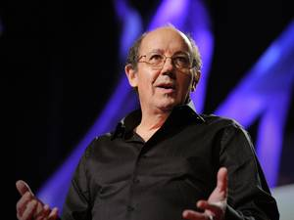[17:40](https://www.ted.com/talks/david_christian_big_history)

[David Christian](https://www.ted.com/speakers/david_christian) [The history of our world in 18 minutes](https://www.ted.com/talks/david_christian_big_history)

Backed by stunning illustrations, David Christian narrates a complete history of the universe, from the Big Bang to the Internet, in a riveting 18 minutes. This is "Big History": an enlightening, wide-angle look at complexity, life and humanity, set against our slim share of the cosmic timeline.

[Watch later](https://www.ted.com/session/new) · [462 comments](https://www.ted.com/talks/david_christian_big_history)