#### [Tech breakthrough](https://www.ted.com/playlists/2/tech_breakthrough)

**Playlist (14 talks): Tech breakthrough**

These onstage demos offer a mind-blowing peek at where technology is taking us. Flying robots, levitating superconductors, brainwave-reading headsets and more …

* 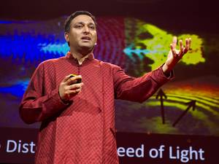[11:02](https://www.ted.com/talks/ramesh_raskar_a_camera_that_takes_one_trillion_frames_per_second)

[Ramesh Raskar](https://www.ted.com/speakers/ramesh_raskar) [Imaging at a trillion frames per second](https://www.ted.com/talks/ramesh_raskar_a_camera_that_takes_one_trillion_frames_per_second)

Ramesh Raskar presents femto-photography, a new type of imaging so fast it visualizes the world one trillion frames per second, so detailed it shows light itself in motion. This technology may someday be used to build cameras that can look “around” corners or see inside the body without X-rays.

[Watch later](https://www.ted.com/session/new) · [349 comments](https://www.ted.com/talks/ramesh_raskar_a_camera_that_takes_one_trillion_frames_per_second)

* [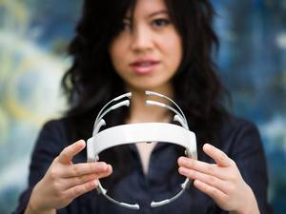10:36](https://www.ted.com/talks/tan_le_a_headset_that_reads_your_brainwaves)

[Tan Le](https://www.ted.com/speakers/tan_le) [A headset that reads your brainwaves](https://www.ted.com/talks/tan_le_a_headset_that_reads_your_brainwaves)

Tan Le's astonishing new computer interface reads its user's brainwaves, making it possible to control virtual objects, and even physical electronics, with mere thoughts (and a little concentration). She demos the headset, and talks about its far-reaching applications.

[Watch later](https://www.ted.com/session/new) · [558 comments](https://www.ted.com/talks/tan_le_a_headset_that_reads_your_brainwaves)

* [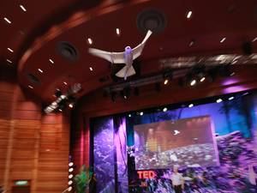6:19](https://www.ted.com/talks/a_robot_that_flies_like_a_bird)

[Markus Fischer](https://www.ted.com/speakers/markus_fischer" \t "_blank) [A robot that flies like a bird](https://www.ted.com/talks/a_robot_that_flies_like_a_bird)

Plenty of robots can fly — but none can fly like a real bird. That is, until Markus Fischer and his team at Festo built SmartBird, a large, lightweight robot, modeled on a seagull, that flies by flapping its wings. A soaring demo fresh from TEDGlobal 2011.

[Watch later](https://www.ted.com/session/new) · [424 comments](https://www.ted.com/talks/a_robot_that_flies_like_a_bird)

* [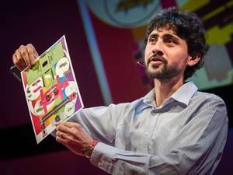9:21](https://www.ted.com/talks/manu_prakash_a_50_cent_microscope_that_folds_like_origami)

[Manu Prakash](https://www.ted.com/speakers/manu_prakash) [A 50-cent microscope that folds like origami](https://www.ted.com/talks/manu_prakash_a_50_cent_microscope_that_folds_like_origami)

Perhaps you’ve punched out a paper doll or folded an origami swan? TED Fellow Manu Prakash and his team have created a microscope made of paper that's just as easy to fold and use. A sparkling demo that shows how this invention could revolutionize healthcare in developing countries … and turn almost anything into a fun, hands-on science experiment.

[Watch later](https://www.ted.com/session/new) · [185 comments](https://www.ted.com/talks/manu_prakash_a_50_cent_microscope_that_folds_like_origami)

* [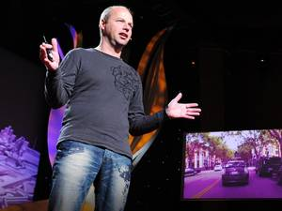4:14](https://www.ted.com/talks/sebastian_thrun_google_s_driverless_car)

[Sebastian Thrun](https://www.ted.com/speakers/sebastian_thrun) [Google's driverless car](https://www.ted.com/talks/sebastian_thrun_google_s_driverless_car)

Sebastian Thrun helped build Google's amazing driverless car, powered by a very personal quest to save lives and reduce traffic accidents. Jawdropping video shows the DARPA Challenge-winning car motoring through busy city traffic with no one behind the wheel, and dramatic test drive footage from TED2011 demonstrates how fast the thing can really go.

[Watch later](https://www.ted.com/session/new) · [263 comments](https://www.ted.com/talks/sebastian_thrun_google_s_driverless_car)

* [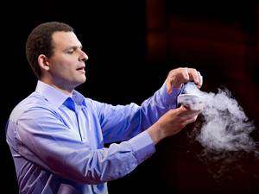10:25](https://www.ted.com/talks/boaz_almog_levitates_a_superconductor)

[Boaz Almog](https://www.ted.com/speakers/boaz_almog) [The levitating superconductor](https://www.ted.com/talks/boaz_almog_levitates_a_superconductor)

How can a super-thin 3-inch disk levitate something 70,000 times its own weight? In a riveting demonstration, Boaz Almog shows how a phenomenon known as quantum locking allows a superconductor disk to float over a magnetic rail — completely frictionlessly and with zero energy loss. Experiment: Prof. Guy Deutscher, Mishael Azoulay, Boaz Almog, of the High Tc Superconductivity Group, School of Physics and Astronomy, Tel Aviv University.

[Watch later](https://www.ted.com/session/new) · [271 comments](https://www.ted.com/talks/boaz_almog_levitates_a_superconductor)

* [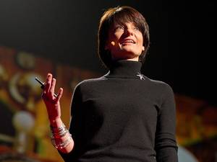25:01](https://www.ted.com/talks/regina_dugan_from_mach_20_glider_to_humming_bird_drone)

[Regina Dugan](https://www.ted.com/speakers/regina_dugan) [From mach-20 glider to hummingbird drone](https://www.ted.com/talks/regina_dugan_from_mach_20_glider_to_humming_bird_drone)

"What would you attempt to do if you knew you could not fail?" asks Regina Dugan, then director of DARPA, the Defense Advanced Research Projects Agency. In this breathtaking talk she describes some of the extraordinary projects — a robotic hummingbird, a prosthetic arm controlled by thought, and, well, the internet — that her agency has created by not worrying that they might fail. (Followed by a Q&A with TED's Chris Anderson)

[Watch later](https://www.ted.com/session/new) · [489 comments](https://www.ted.com/talks/regina_dugan_from_mach_20_glider_to_humming_bird_drone)

* [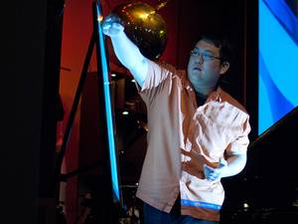5:40](https://www.ted.com/talks/johnny_lee_demos_wii_remote_hacks)

[Johnny Lee](https://www.ted.com/speakers/johnny_lee) [Free or cheap Wii Remote hacks](https://www.ted.com/talks/johnny_lee_demos_wii_remote_hacks)

Building sophisticated educational tools out of cheap parts, Johnny Lee demos his cool Wii Remote hacks, which turn the $40 video game controller into a digital whiteboard, a touchscreen and a head-mounted 3-D viewer.

[Watch later](https://www.ted.com/session/new) · [255 comments](https://www.ted.com/talks/johnny_lee_demos_wii_remote_hacks)

* [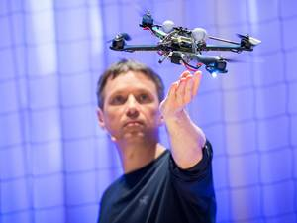16:08](https://www.ted.com/talks/raffaello_d_andrea_the_astounding_athletic_power_of_quadcopters)

[Raffaello D'Andrea](https://www.ted.com/speakers/raffaello_d_andrea) [The astounding athletic power of quadcopters](https://www.ted.com/talks/raffaello_d_andrea_the_astounding_athletic_power_of_quadcopters)

In a robot lab at TEDGlobal, Raffaello D'Andrea demos his flying quadcopters: robots that think like athletes, solving physical problems with algorithms that help them learn. In a series of nifty demos, D'Andrea show drones that play catch, balance and make decisions together — and watch out for an I-want-this-now demo of Kinect-controlled quads.

[Watch later](https://www.ted.com/session/new) · [281 comments](https://www.ted.com/talks/raffaello_d_andrea_the_astounding_athletic_power_of_quadcopters)

* [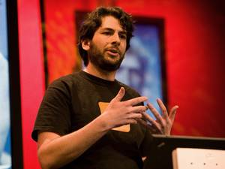7:30](https://www.ted.com/talks/blaise_aguera_y_arcas_demos_photosynth)

[Blaise Aguera y Arcas](https://www.ted.com/speakers/blaise_aguera_y_arcas) [How PhotoSynth can connect the world's images](https://www.ted.com/talks/blaise_aguera_y_arcas_demos_photosynth)

Blaise Aguera y Arcas leads a dazzling demo of Photosynth, software that could transform the way we look at digital images. Using still photos culled from the Web, Photosynth builds breathtaking dreamscapes and lets us navigate them.

[Watch later](https://www.ted.com/session/new) · [252 comments](https://www.ted.com/talks/blaise_aguera_y_arcas_demos_photosynth)

* [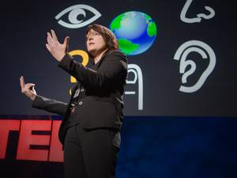8:42](https://www.ted.com/talks/pattie_maes_demos_the_sixth_sense)

[Pattie Maes](https://www.ted.com/speakers/pattie_maes), [Pranav Mistry](https://www.ted.com/speakers/pranav_mistry) [Meet the SixthSense interaction](https://www.ted.com/talks/pattie_maes_demos_the_sixth_sense)

This demo — from Pattie Maes' lab at MIT, spearheaded by Pranav Mistry — was the buzz of TED. It's a wearable device with a projector that paves the way for profound interaction with our environment. Imagine "Minority Report" and then some.

[Watch later](https://www.ted.com/session/new) · [731 comments](https://www.ted.com/talks/pattie_maes_demos_the_sixth_sense)

* [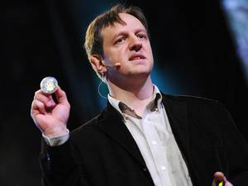12:51](https://www.ted.com/talks/harald_haas_wireless_data_from_every_light_bulb)

[Harald Haas](https://www.ted.com/speakers/harald_haas) [Wireless data from every light bulb](https://www.ted.com/talks/harald_haas_wireless_data_from_every_light_bulb)

What if every light bulb in the world could also transmit data? At TEDGlobal, Harald Haas demonstrates, for the first time, a device that could do exactly that. By flickering the light from a single LED, a change too quick for the human eye to detect, he can transmit far more data than a cellular tower — and do it in a way that's more efficient, secure and widespread.

[Watch later](https://www.ted.com/session/new) · [333 comments](https://www.ted.com/talks/harald_haas_wireless_data_from_every_light_bulb)

* 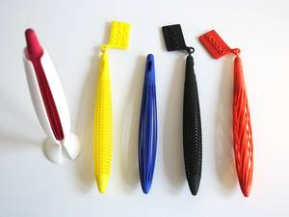[14:49](https://www.ted.com/talks/lisa_harouni_a_primer_on_3d_printing" \t "_blank)

[Now playing](https://www.ted.com/talks/lisa_harouni_a_primer_on_3d_printing" \t "_blank)

[Lisa Harouni](https://www.ted.com/speakers/lisa_harouni) [A primer on 3D printing](https://www.ted.com/talks/lisa_harouni_a_primer_on_3d_printing)

2012 may be the year of 3D printing, when this three-decade-old technology finally becomes accessible and even commonplace. Lisa Harouni gives a useful introduction to this fascinating way of making things — including intricate objects once impossible to create.

[Watch later](https://www.ted.com/session/new) · [218 comments](https://www.ted.com/talks/lisa_harouni_a_primer_on_3d_printing)

* [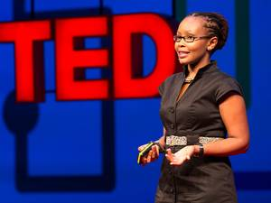9:33](https://www.ted.com/talks/juliana_rotich_meet_brck_internet_access_built_for_africa)

[Juliana Rotich](https://www.ted.com/speakers/juliana_rotich) [Meet BRCK, Internet access built for Africa](https://www.ted.com/talks/juliana_rotich_meet_brck_internet_access_built_for_africa)

Tech communities are booming all over Africa, says Nairobi-based Juliana Rotich, cofounder of the open-source software Ushahidi. But it remains challenging to get and stay connected in a region with frequent blackouts and spotty Internet hookups. So Rotich and friends developed BRCK, offering resilient connectivity for the developing world.

[Watch later](https://www.ted.com/session/new) · [112 comments](https://www.ted.com/talks/juliana_rotich_meet_brck_internet_access_built_for_africa)