**Playlist (14 talks): The dark side of data**

Data can be used for good, harnessed for the betterment of society, but it can also be abused. Find out about some hidden not-so-sunny uses of Big Data.

* [9:56](https://www.ted.com/talks/malte_spitz_your_phone_company_is_watching" \t "_blank)

[Now playing](https://www.ted.com/talks/malte_spitz_your_phone_company_is_watching" \t "_blank)

[Malte Spitz](https://www.ted.com/speakers/malte_spitz) [Your phone company is watching](https://www.ted.com/talks/malte_spitz_your_phone_company_is_watching)

What kind of data is your cell phone company collecting? Malte Spitz wasn’t too worried when he asked his operator in Germany to share information stored about him. Multiple unanswered requests and a lawsuit later, Spitz received 35,830 lines of code — a detailed, nearly minute-by-minute account of half a year of his life.

[Watch later](https://www.ted.com/session/new) · [222 comments](https://www.ted.com/talks/malte_spitz_your_phone_company_is_watching)

* [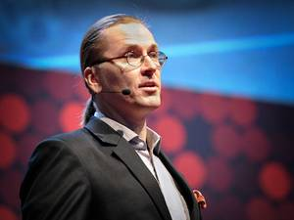19:18](https://www.ted.com/talks/mikko_hypponen_how_the_nsa_betrayed_the_world_s_trust_time_to_act)

[Mikko Hypponen](https://www.ted.com/speakers/mikko_hypponen) [How the NSA betrayed the world's trust -- time to act](https://www.ted.com/talks/mikko_hypponen_how_the_nsa_betrayed_the_world_s_trust_time_to_act)

Recent events have highlighted, underlined and bolded the fact that the United States is performing blanket surveillance on any foreigner whose data passes through an American entity — whether they are suspected of wrongdoing or not. This means that, essentially, every international user of the internet is being watched, says Mikko Hypponen. An important rant, wrapped with a plea: to find alternative solutions to using American companies for the world's information needs.

[Watch later](https://www.ted.com/session/new) · [501 comments](https://www.ted.com/talks/mikko_hypponen_how_the_nsa_betrayed_the_world_s_trust_time_to_act)

* [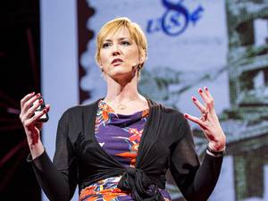18:57](https://www.ted.com/talks/heather_brooke_my_battle_to_expose_government_corruption)

[Heather Brooke](https://www.ted.com/speakers/heather_brooke) [My battle to expose government corruption](https://www.ted.com/talks/heather_brooke_my_battle_to_expose_government_corruption)

Our leaders need to be held accountable, says journalist Heather Brooke. And she should know: Brooke uncovered the British Parliamentary financial expenses that led to a major political scandal in 2009. She urges us to ask our leaders questions through platforms like Freedom of Information requests — and to finally get some answers.

[Watch later](https://www.ted.com/session/new) · [124 comments](https://www.ted.com/talks/heather_brooke_my_battle_to_expose_government_corruption)

* [14:19](https://www.ted.com/talks/ben_goldacre_battling_bad_science)

[Ben Goldacre](https://www.ted.com/speakers/ben_goldacre) [Battling bad science](https://www.ted.com/talks/ben_goldacre_battling_bad_science)

Every day there are news reports of new health advice, but how can you know if they're right? Doctor and epidemiologist Ben Goldacre shows us, at high speed, the ways evidence can be distorted, from the blindingly obvious nutrition claims to the very subtle tricks of the pharmaceutical industry.

[Watch later](https://www.ted.com/session/new) · [298 comments](https://www.ted.com/talks/ben_goldacre_battling_bad_science)

* [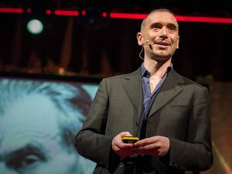15:00](https://www.ted.com/talks/alessandro_acquisti_why_privacy_matters)

[Alessandro Acquisti](https://www.ted.com/speakers/alessandro_acquisti) [What will a future without secrets look like?](https://www.ted.com/talks/alessandro_acquisti_why_privacy_matters)

The line between public and private has blurred in the past decade, both online and in real life, and Alessandro Acquisti is here to explain what this means and why it matters. In this thought-provoking, slightly chilling talk, he shares details of recent and ongoing research — including a project that shows how easy it is to match a photograph of a stranger with their sensitive personal information.

[Watch later](https://www.ted.com/session/new) · [126 comments](https://www.ted.com/talks/alessandro_acquisti_why_privacy_matters)

* 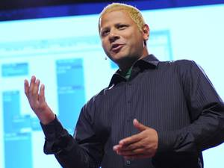[14:30](https://www.ted.com/talks/hasan_elahi)

[Hasan Elahi](https://www.ted.com/speakers/hasan_elahi) [FBI, here I am!](https://www.ted.com/talks/hasan_elahi)

After he ended up on a watch list by accident, Hasan Elahi was advised by his local FBI agents to let them know when he was traveling. He did that and more ... much more.

[Watch later](https://www.ted.com/session/new) · [130 comments](https://www.ted.com/talks/hasan_elahi)

* [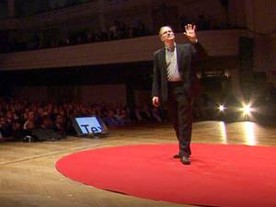9:23](https://www.ted.com/talks/mikko_hypponen_three_types_of_online_attack)

[Mikko Hypponen](https://www.ted.com/speakers/mikko_hypponen) [Three types of online attack](https://www.ted.com/talks/mikko_hypponen_three_types_of_online_attack)

Cybercrime expert Mikko Hypponen talks us through three types of online attack on our privacy and data — and only two are considered crimes. "Do we blindly trust any future government? Because any right we give away, we give away for good." (Filmed at TEDxBrussels.)

[Watch later](https://www.ted.com/session/new) · [107 comments](https://www.ted.com/talks/mikko_hypponen_three_types_of_online_attack)

* [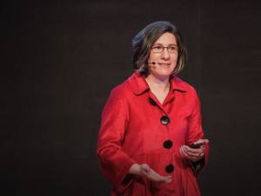17:41](https://www.ted.com/talks/lorrie_faith_cranor_what_s_wrong_with_your_pa_w0rd)

[Lorrie Faith Cranor](https://www.ted.com/speakers/lorrie_faith_cranor) [What’s wrong with your pa$$w0rd?](https://www.ted.com/talks/lorrie_faith_cranor_what_s_wrong_with_your_pa_w0rd)

Lorrie Faith Cranor studied thousands of real passwords to figure out the surprising, very common mistakes that users — and secured sites — make to compromise security. And how, you may ask, did she study thousands of real passwords without compromising the security of any users? That's a story in itself. It's secret data worth knowing, especially if your password is 123456 ...

[Watch later](https://www.ted.com/session/new) · [79 comments](https://www.ted.com/talks/lorrie_faith_cranor_what_s_wrong_with_your_pa_w0rd)

* [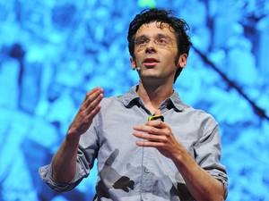15:22](https://www.ted.com/talks/kevin_slavin_how_algorithms_shape_our_world)

[Kevin Slavin](https://www.ted.com/speakers/kevin_slavin) [How algorithms shape our world](https://www.ted.com/talks/kevin_slavin_how_algorithms_shape_our_world)

We live in a world run by algorithms, computer programs that make decisions or solve problems for us. In this riveting, funny talk, Kevin Slavin shows how modern algorithms determine stock prices, espionage tactics, even the movies you watch. But, he asks: If we depend on complex algorithms to manage our daily decisions — when do we start to lose control?

[Watch later](https://www.ted.com/session/new) · [282 comments](https://www.ted.com/talks/kevin_slavin_how_algorithms_shape_our_world)

* [9:55](https://www.ted.com/talks/jennifer_golbeck_the_curly_fry_conundrum_why_social_media_likes_say_more_than_you_might_think)

[Jennifer Golbeck](https://www.ted.com/speakers/jennifer_golbeck) [The curly fry conundrum: Why social media “likes” say more than you might think](https://www.ted.com/talks/jennifer_golbeck_the_curly_fry_conundrum_why_social_media_likes_say_more_than_you_might_think)

Do you like curly fries? Have you Liked them on Facebook? Watch this talk to find out the surprising things Facebook (and others) can guess about you from your random Likes and Shares. Computer scientist Jennifer Golbeck explains how this came about, how some applications of the technology are not so cute — and why she thinks we should return the control of information to its rightful owners.

[Watch later](https://www.ted.com/session/new) · [103 comments](https://www.ted.com/talks/jennifer_golbeck_the_curly_fry_conundrum_why_social_media_likes_say_more_than_you_might_think)

* [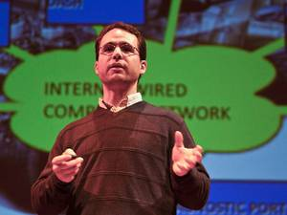16:56](https://www.ted.com/talks/avi_rubin_all_your_devices_can_be_hacked)

[Avi Rubin](https://www.ted.com/speakers/avi_rubin) [All your devices can be hacked](https://www.ted.com/talks/avi_rubin_all_your_devices_can_be_hacked)

Could someone hack your pacemaker? At TEDxMidAtlantic, Avi Rubin explains how hackers are compromising cars, smartphones and medical devices, and warns us about the dangers of an increasingly hack-able world. (Filmed at TEDxMidAtlantic.)

[Watch later](https://www.ted.com/session/new) · [97 comments](https://www.ted.com/talks/avi_rubin_all_your_devices_can_be_hacked)

* [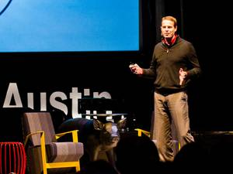15:45](https://www.ted.com/talks/todd_humphreys_how_to_fool_a_gps)

[Todd Humphreys](https://www.ted.com/speakers/todd_humphreys) [How to fool a GPS](https://www.ted.com/talks/todd_humphreys_how_to_fool_a_gps)

Todd Humphreys forecasts the near-future of geolocation when millimeter-accurate GPS "dots" will enable you to find pin-point locations, index-search your physical possessions ... or to track people without their knowledge. And the response to the sinister side of this technology may have unintended consequences of its own. (Filmed at TEDxAustin.)

[Watch later](https://www.ted.com/session/new) · [146 comments](https://www.ted.com/talks/todd_humphreys_how_to_fool_a_gps)

* [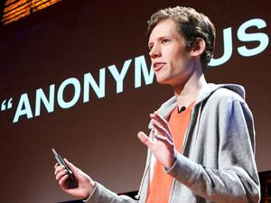13:10](https://www.ted.com/talks/christopher_m00t_poole_the_case_for_anonymity_online)

[Christopher "moot" Poole](https://www.ted.com/speakers/christopher_moot_poole) [The case for anonymity online](https://www.ted.com/talks/christopher_m00t_poole_the_case_for_anonymity_online)

The founder of 4chan, a controversial, uncensored online imageboard, describes its subculture, some of the Internet "memes" it has launched, and the incident in which its users managed a very public, precision hack of a mainstream media website. The talk raises questions about the power — and price — of anonymity.

[Watch later](https://www.ted.com/session/new) · [466 comments](https://www.ted.com/talks/christopher_m00t_poole_the_case_for_anonymity_online)

* [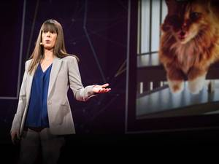9:19](https://www.ted.com/talks/del_harvey_the_strangeness_of_scale_at_twitter)

[Del Harvey](https://www.ted.com/speakers/del_harvey) [Protecting Twitter users (sometimes from themselves)](https://www.ted.com/talks/del_harvey_the_strangeness_of_scale_at_twitter)

Del Harvey heads up Twitter’s Trust and Safety Team, and she thinks all day about how to prevent worst-case scenarios — abuse, trolling, stalking — while giving voice to people around the globe. With deadpan humor, she offers a window into how she works to keep 240 million users safe.

[Watch later](https://www.ted.com/session/new) · [74 comments](https://www.ted.com/talks/del_harvey_the_strangeness_of_scale_at_twitter)