**Playlist (14 talks): What does the future look like?**

#### [What does the future look like?](https://www.ted.com/playlists/85/what_does_the_future_look_like)

Visions of the future, on everything from cars to the Internet to the human species.

* [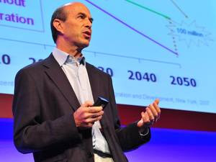7:06](https://www.ted.com/talks/ian_goldin_navigating_our_global_future)

[Ian Goldin](https://www.ted.com/speakers/ian_goldin) [Navigating our global future](https://www.ted.com/talks/ian_goldin_navigating_our_global_future)

As globalization and technological advances bring us hurtling towards a new integrated future, Ian Goldin warns that not all people may benefit equally. But, he says, if we can recognize this danger, we might yet realize the possibility of improved life for everyone.

[Watch later](https://www.ted.com/session/new) · [101 comments](https://www.ted.com/talks/ian_goldin_navigating_our_global_future)

* [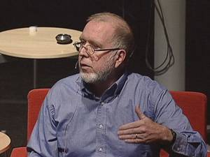19:34](https://www.ted.com/talks/kevin_kelly_on_the_next_5_000_days_of_the_web)

[Kevin Kelly](https://www.ted.com/speakers/kevin_kelly) [The next 5,000 days of the web](https://www.ted.com/talks/kevin_kelly_on_the_next_5_000_days_of_the_web)

At the 2007 EG conference, Kevin Kelly shares a fun stat: The World Wide Web, as we know it, is only 5,000 days old. Now, Kelly asks, how can we predict what's coming in the next 5,000 days?

[Watch later](https://www.ted.com/session/new) · [229 comments](https://www.ted.com/talks/kevin_kelly_on_the_next_5_000_days_of_the_web)

* 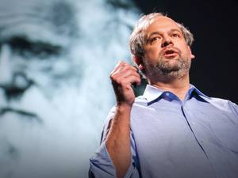[18:50](https://www.ted.com/talks/juan_enriquez_shares_mindboggling_new_science)

[Juan Enriquez](https://www.ted.com/speakers/juan_enriquez) [The next species of human](https://www.ted.com/talks/juan_enriquez_shares_mindboggling_new_science)

Even as mega-banks topple, Juan Enriquez says the big reboot is yet to come. But don't look for it on your ballot — or in the stock exchange. It'll come from science labs, and it promises keener bodies and minds. Our kids are going to be ... different.

[Watch later](https://www.ted.com/session/new) · [395 comments](https://www.ted.com/talks/juan_enriquez_shares_mindboggling_new_science)

* [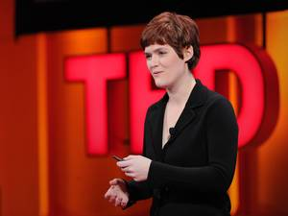7:53](https://www.ted.com/talks/amber_case_we_are_all_cyborgs_now)

[Amber Case](https://www.ted.com/speakers/amber_case) [We are all cyborgs now](https://www.ted.com/talks/amber_case_we_are_all_cyborgs_now)

Technology is evolving us, says Amber Case, as we become a screen-staring, button-clicking new version of homo sapiens. We now rely on "external brains" (cell phones and computers) to communicate, remember, even live out secondary lives. But will these machines ultimately connect or conquer us? Case offers surprising insight into our cyborg selves.

[Watch later](https://www.ted.com/session/new) · [231 comments](https://www.ted.com/talks/amber_case_we_are_all_cyborgs_now)

* 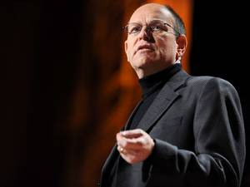[3:21](https://www.ted.com/talks/kirk_citron_and_now_the_real_news)

[Kirk Citron](https://www.ted.com/speakers/kirk_citron) [And now, the real news](https://www.ted.com/talks/kirk_citron_and_now_the_real_news)

How many of today's headlines will matter in 100 years? 1000? Kirk Citron's "Long News" project collects stories that not only matter today, but will resonate for decades — even centuries — to come. At TED2010, he highlights recent headlines with the potential to shape our future.

[Watch later](https://www.ted.com/session/new) · [136 comments](https://www.ted.com/talks/kirk_citron_and_now_the_real_news)

* [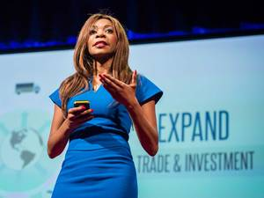16:23](https://www.ted.com/talks/dambisa_moyo_is_china_the_new_idol_for_emerging_economies)

[Dambisa Moyo](https://www.ted.com/speakers/dambisa_moyo) [Is China the new idol for emerging economies?](https://www.ted.com/talks/dambisa_moyo_is_china_the_new_idol_for_emerging_economies)

The developed world holds up the ideals of capitalism, democracy and political rights for all. Those in emerging markets often don't have that luxury. In this powerful talk, economist Dambisa Moyo makes the case that the west can't afford to rest on its laurels and imagine others will blindly follow. Instead, a different model, embodied by China, is increasingly appealing. A call for open-minded political and economic cooperation in the name of transforming the world.

[Watch later](https://www.ted.com/session/new) · [754 comments](https://www.ted.com/talks/dambisa_moyo_is_china_the_new_idol_for_emerging_economies)

* [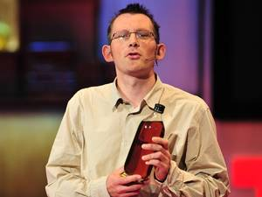16:40](https://www.ted.com/talks/rob_hopkins_transition_to_a_world_without_oil)

[Rob Hopkins](https://www.ted.com/speakers/rob_hopkins) [Transition to a world without oil](https://www.ted.com/talks/rob_hopkins_transition_to_a_world_without_oil)

Rob Hopkins reminds us that the oil our world depends on is steadily running out. He proposes a unique solution to this problem — the Transition response, where we prepare ourselves for life without oil and sacrifice our luxuries to build systems and communities that are completely independent of fossil fuels.

[Watch later](https://www.ted.com/session/new) · [199 comments](https://www.ted.com/talks/rob_hopkins_transition_to_a_world_without_oil)

* 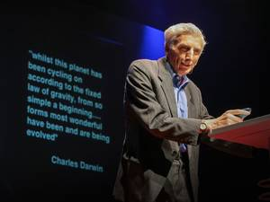[17:26](https://www.ted.com/talks/martin_rees_asks_is_this_our_final_century)

[Martin Rees](https://www.ted.com/speakers/sir_martin_rees) [Is this our final century?](https://www.ted.com/talks/martin_rees_asks_is_this_our_final_century)

Speaking as both an astronomer and "a concerned member of the human race," Sir Martin Rees examines our planet and its future from a cosmic perspective. He urges action to prevent dark consequences from our scientific and technological development.

[Watch later](https://www.ted.com/session/new) · [179 comments](https://www.ted.com/talks/martin_rees_asks_is_this_our_final_century)

* 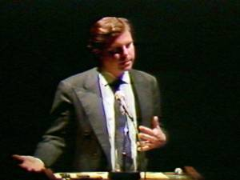[25:23](https://www.ted.com/talks/nicholas_negroponte_in_1984_makes_5_predictions)

[Nicholas Negroponte](https://www.ted.com/speakers/nicholas_negroponte) [5 predictions, from 1984](https://www.ted.com/talks/nicholas_negroponte_in_1984_makes_5_predictions)

With surprising accuracy, Nicholas Negroponte predicts what will happen with CD-ROMs, web interfaces, service kiosks, the touchscreen interface of the iPhone and his own One Laptop per Child project.

[Watch later](https://www.ted.com/session/new) · [56 comments](https://www.ted.com/talks/nicholas_negroponte_in_1984_makes_5_predictions)

* [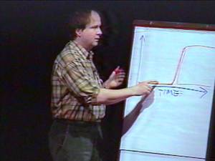19:10](https://www.ted.com/talks/danny_hillis_back_to_the_future_of_1994)

[Danny Hillis](https://www.ted.com/speakers/danny_hillis) [Back to the future (of 1994)](https://www.ted.com/talks/danny_hillis_back_to_the_future_of_1994)

From deep in the TED archive, Danny Hillis outlines an intriguing theory of how and why technological change seems to be accelerating, by linking it to the very evolution of life itself. The presentation techniques he uses may look dated, but the ideas are as relevant as ever.

[Watch later](https://www.ted.com/session/new) · [68 comments](https://www.ted.com/talks/danny_hillis_back_to_the_future_of_1994)

* [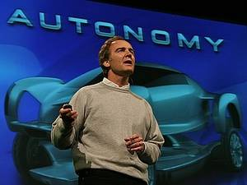9:12](https://www.ted.com/talks/reinventing_the_car)

[Larry Burns](https://www.ted.com/speakers/larry_burns) [The future of cars](https://www.ted.com/talks/reinventing_the_car)

General Motors veep Larry Burns previews cool next-gen car design: sleek, customizable (and computer-enhanced) vehicles that run clean on hydrogen — and pump energy back into the electrical grid when they're idle.

[Watch later](https://www.ted.com/session/new) · [123 comments](https://www.ted.com/talks/reinventing_the_car)

* 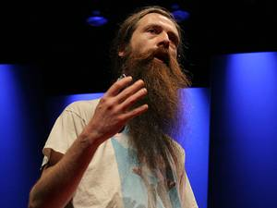[22:45](https://www.ted.com/talks/aubrey_de_grey_says_we_can_avoid_aging)

[Aubrey de Grey](https://www.ted.com/speakers/aubrey_de_grey) [A roadmap to end aging](https://www.ted.com/talks/aubrey_de_grey_says_we_can_avoid_aging)

Cambridge researcher Aubrey de Grey argues that aging is merely a disease — and a curable one at that. Humans age in seven basic ways, he says, all of which can be averted.

[Watch later](https://www.ted.com/session/new) · [528 comments](https://www.ted.com/talks/aubrey_de_grey_says_we_can_avoid_aging)

* [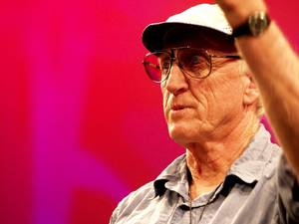23:23](https://www.ted.com/talks/stewart_brand_on_the_long_now)

[Stewart Brand](https://www.ted.com/speakers/stewart_brand) [The Long Now](https://www.ted.com/talks/stewart_brand_on_the_long_now)

Stewart Brand works on the Clock of the Long Now, a timepiece that counts down the next 10,000 years. It's a beautiful project that asks us to think about the far, far future. Here, he discusses a tricky side problem with the Clock: Where can we put it?

[Watch later](https://www.ted.com/session/new) · [53 comments](https://www.ted.com/talks/stewart_brand_on_the_long_now)

* [18:36](https://www.ted.com/talks/sarah_jones_what_does_the_future_hold_11_characters_offer_quirky_answers)

[Sarah Jones](https://www.ted.com/speakers/sarah_jones) [What does the future hold? 11 characters offer quirky answers](https://www.ted.com/talks/sarah_jones_what_does_the_future_hold_11_characters_offer_quirky_answers)

Sarah Jones changes personas with the simplest of wardrobe swaps. In a laugh-out-loud improvisation, she invites 11 "friends" from the future on stage—from a fast-talking Latina to an outspoken police officer—to ask them questions supplied by the TED2014 audience.

[Watch later](https://www.ted.com/session/new) · [76 comments](https://www.ted.com/talks/sarah_jones_what_does_the_future_hold_11_characters_offer_quirky_answers)