# TED Playlists

TED Talk collections for curious minds

[See all 11 playlists on Technology](https://www.ted.com/playlists/browse?topics=technology)

[**Should we redesign humans?**](https://www.ted.com/playlists/144/should_we_redesign_humans)

10 talks • 2h 15m   
Curated by TED

[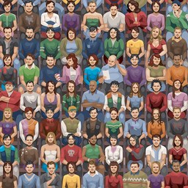](https://www.ted.com/playlists/141/moocs_101)

[**MOOCs 101**](https://www.ted.com/playlists/141/moocs_101)

7 talks • 1h 48m   
Curated by TED

[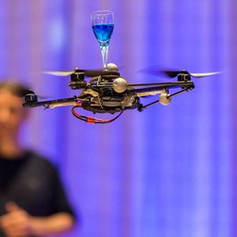](https://www.ted.com/playlists/135/will_drones_save_us_or_destroy)

[**Will drones save us or destroy us?**](https://www.ted.com/playlists/135/will_drones_save_us_or_destroy)

14 talks • 3h 42m   
Curated by TED

[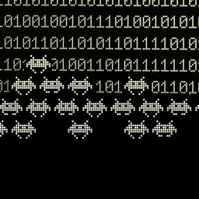](https://www.ted.com/playlists/130/the_dark_side_of_data)

[**The dark side of data**](https://www.ted.com/playlists/130/the_dark_side_of_data)

14 talks • 3h 19m   
Curated by TED

[](https://www.ted.com/playlists/85/what_does_the_future_look_like)

[**What does the future look like?**](https://www.ted.com/playlists/85/what_does_the_future_look_like)

14 talks • 3h 45m   
Curated by TED

[](https://www.ted.com/playlists/83/planes_trains_and_automobiles)

[**Planes, trains and automobiles**](https://www.ted.com/playlists/83/planes_trains_and_automobiles)

14 talks • 3h 30m   
Curated by TED

[](https://www.ted.com/playlists/77/11_must_see_ted_talks)

[**11 must-see TED Talks**](https://www.ted.com/playlists/77/11_must_see_ted_talks)

11 talks • 3h 08m   
Curated by TED

[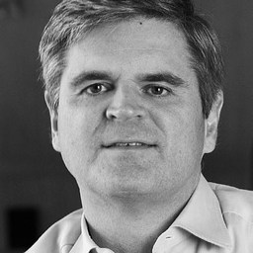](https://www.ted.com/playlists/51/steve_case_10_unforgettable_t)

[**Steve Case: 10 unforgettable talks**](https://www.ted.com/playlists/51/steve_case_10_unforgettable_t)

10 talks • 3h 14m   
Curated by Steve Case

[](https://www.ted.com/playlists/17/how_to_live_with_robots)

[**How to live with robots**](https://www.ted.com/playlists/17/how_to_live_with_robots)

10 talks • 2h 10m   
Curated by TED

[](https://www.ted.com/playlists/10/who_are_the_hackers)

[**Who are the hackers?**](https://www.ted.com/playlists/10/who_are_the_hackers)

9 talks • 2h 12m   
Curated by TED

[](https://www.ted.com/playlists/2/tech_breakthrough)

[**Tech breakthrough**](https://www.ted.com/playlists/2/tech_breakthrough)

14 talks • 2h 32m   
Curated by TED