**[Planes, trains and automobiles](https://www.ted.com/playlists/83/planes_trains_and_automobiles)**

## Playlist (14 talks): Planes, trains and automobiles

Drive a plane? Race a car with your eyes closed? Fly? Innovators in transportation show that getting from point A to point B doesn't have to be boring.

* [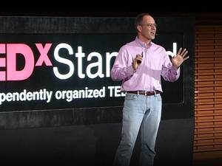10:47](https://www.ted.com/talks/chris_gerdes_the_future_race_car_150mph_and_no_driver)

[Chris Gerdes](https://www.ted.com/speakers/chris_gerdes) [The future race car -- 150mph, and no driver](https://www.ted.com/talks/chris_gerdes_the_future_race_car_150mph_and_no_driver)

Autonomous cars are coming — and they’re going to drive better than you. Chris Gerdes reveals how he and his team are developing robotic race cars that can drive at 150 mph while avoiding every possible accident. And yet, in studying the brainwaves of professional racing drivers, Gerdes says he has gained a new appreciation for the instincts of professional drivers. (Filmed at TEDxStanford.)

[Watch later](https://www.ted.com/session/new) · [102 comments](https://www.ted.com/talks/chris_gerdes_the_future_race_car_150mph_and_no_driver)

* [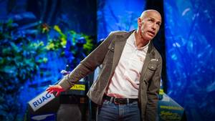14:48](https://www.ted.com/talks/yves_rossy_fly_with_the_jetman)

[Yves Rossy](https://www.ted.com/speakers/yves_rossy) [Fly with the Jetman](https://www.ted.com/talks/yves_rossy_fly_with_the_jetman)

Strapped to a jet-powered wing, Yves Rossy is the Jetman — flying free, his body as the rudder, above the Swiss Alps and the Grand Canyon. After a powerful short film shows how it works, Rossy takes the TEDGlobal stage to share the experience and thrill of flying.

[Watch later](https://www.ted.com/session/new) · [107 comments](https://www.ted.com/talks/yves_rossy_fly_with_the_jetman)

* [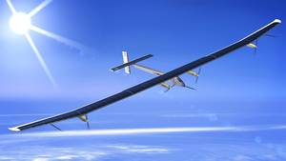17:46](https://www.ted.com/talks/bertrand_piccard_s_solar_powered_adventure)

[Bertrand Piccard](https://www.ted.com/speakers/bertrand_piccard) [My solar-powered adventure](https://www.ted.com/talks/bertrand_piccard_s_solar_powered_adventure)

For the dawn of a new decade, adventurer Bertrand Piccard offers us a challenge: Find motivation in what seems impossible. He shares his own plans to do what many say can't be done — to fly around the world, day and night, in a solar-powered aircraft.

[Watch later](https://www.ted.com/session/new) · [89 comments](https://www.ted.com/talks/bertrand_piccard_s_solar_powered_adventure)

* 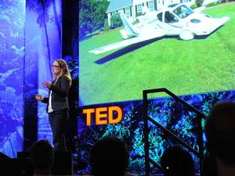[9:38](https://www.ted.com/talks/anna_mracek_dietrich_a_plane_you_can_drive)

[Anna Mracek Dietrich](https://www.ted.com/speakers/anna_mracek_dietrichs) [A plane you can drive](https://www.ted.com/talks/anna_mracek_dietrich_a_plane_you_can_drive)

A flying car — it's an iconic image of the future. But after 100 years of flight and automotive engineering, no one has really cracked the problem. Pilot Anna Mracek Dietrich and her team flipped the question, asking: Why not build a plane that you can drive?

[Watch later](https://www.ted.com/session/new) · [101 comments](https://www.ted.com/talks/anna_mracek_dietrich_a_plane_you_can_drive)

* [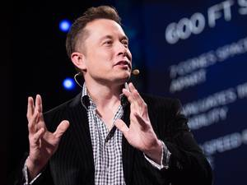21:04](https://www.ted.com/talks/elon_musk_the_mind_behind_tesla_spacex_solarcity)

[Elon Musk](https://www.ted.com/speakers/elon_musk) [The mind behind Tesla, SpaceX, SolarCity ...](https://www.ted.com/talks/elon_musk_the_mind_behind_tesla_spacex_solarcity)

Entrepreneur Elon Musk is a man with many plans. The founder of PayPal, Tesla Motors and SpaceX sits down with TED curator Chris Anderson to share details about his visionary projects, which include a mass-marketed electric car, a solar energy leasing company and a fully reusable rocket.

[Watch later](https://www.ted.com/session/new) · [339 comments](https://www.ted.com/talks/elon_musk_the_mind_behind_tesla_spacex_solarcity)

* [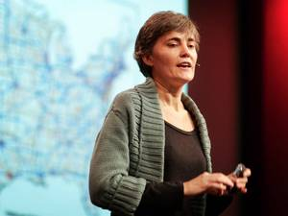13:39](https://www.ted.com/talks/robin_chase_on_zipcar_and_her_next_big_idea)

[Robin Chase](https://www.ted.com/speakers/robin_chase) [The idea behind Zipcar (and what comes next)](https://www.ted.com/talks/robin_chase_on_zipcar_and_her_next_big_idea)

Robin Chase founded Zipcar, the world’s biggest car-sharing business. That was one of her smaller ideas. Here she travels much farther, contemplating road-pricing schemes that will shake up our driving habits and a mesh network vast as the Interstate.

[Watch later](https://www.ted.com/session/new) · [76 comments](https://www.ted.com/talks/robin_chase_on_zipcar_and_her_next_big_idea)

* [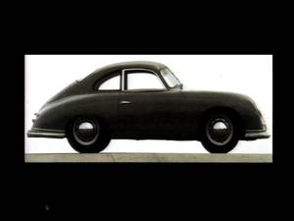20:04](https://www.ted.com/talks/chris_bangle_says_great_cars_are_art)

[Chris Bangle](https://www.ted.com/speakers/chris_bangle) [Great cars are great art](https://www.ted.com/talks/chris_bangle_says_great_cars_are_art)

American designer Chris Bangle explains his philosophy that car design is an art form in its own right, with an entertaining — and ultimately moving — account of the BMW Group's Deep Blue project, intended to create the SUV of the future.

[Watch later](https://www.ted.com/session/new) · [68 comments](https://www.ted.com/talks/chris_bangle_says_great_cars_are_art)

* [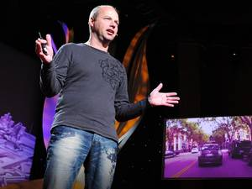4:14](https://www.ted.com/talks/sebastian_thrun_google_s_driverless_car)

[Sebastian Thrun](https://www.ted.com/speakers/sebastian_thrun) [Google's driverless car](https://www.ted.com/talks/sebastian_thrun_google_s_driverless_car)

Sebastian Thrun helped build Google's amazing driverless car, powered by a very personal quest to save lives and reduce traffic accidents. Jawdropping video shows the DARPA Challenge-winning car motoring through busy city traffic with no one behind the wheel, and dramatic test drive footage from TED2011 demonstrates how fast the thing can really go.

[Watch later](https://www.ted.com/session/new) · [263 comments](https://www.ted.com/talks/sebastian_thrun_google_s_driverless_car)

* [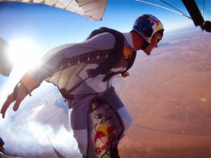12:13](https://www.ted.com/talks/ueli_gegenschatz_extreme_wingsuit_jumping)

[Ueli Gegenschatz](https://www.ted.com/speakers/ueli_gegenschatz) [Extreme wingsuit flying](https://www.ted.com/talks/ueli_gegenschatz_extreme_wingsuit_jumping)

Wingsuit jumping is the leading edge of extreme sports — an exhilarating feat of almost unbelievable daring, where skydivers soar through canyons at over 100MPH. Ueli Gegenschatz talks about how (and why) he does it, and shows jawdropping film.

[Watch later](https://www.ted.com/session/new) · [105 comments](https://www.ted.com/talks/ueli_gegenschatz_extreme_wingsuit_jumping)

* [29:51](https://www.ted.com/talks/richard_branson_s_life_at_30_000_feet)

[Richard Branson](https://www.ted.com/speakers/richard_branson) [Life at 30,000 feet](https://www.ted.com/talks/richard_branson_s_life_at_30_000_feet)

Richard Branson talks to TED's Chris Anderson about the ups and the downs of his career, from his multibillionaire success to his multiple near-death experiences — and reveals some of his (very surprising) motivations.

[Watch later](https://www.ted.com/session/new) · [78 comments](https://www.ted.com/talks/richard_branson_s_life_at_30_000_feet)

* [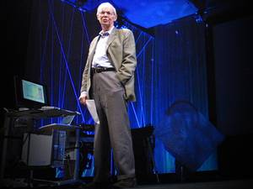21:20](https://www.ted.com/talks/paul_maccready_flies_on_solar_wings)

[Paul MacCready](https://www.ted.com/speakers/paul_maccready) [A flight on solar wings](https://www.ted.com/talks/paul_maccready_flies_on_solar_wings)

Paul MacCready — aircraft designer, environmentalist, and lifelong lover of flight — talks about his long career.

[Watch later](https://www.ted.com/session/new) · [28 comments](https://www.ted.com/talks/paul_maccready_flies_on_solar_wings)

* [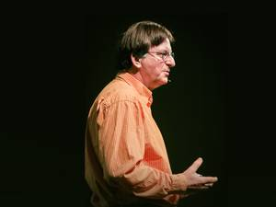12:11](https://www.ted.com/talks/graham_hawkes_flies_through_the_ocean)

[Graham Hawkes](https://www.ted.com/speakers/graham_hawkes) [A flight through the ocean](https://www.ted.com/talks/graham_hawkes_flies_through_the_ocean)

Graham Hawkes takes us aboard his graceful, winged submarines to the depths of planet Ocean (a.k.a. "Earth"). It's a deep blue world we landlubbers rarely see in 3D.

[Watch later](https://www.ted.com/session/new) · [27 comments](https://www.ted.com/talks/graham_hawkes_flies_through_the_ocean)

* [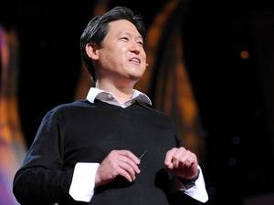9:08](https://www.ted.com/talks/dennis_hong_making_a_car_for_blind_drivers)

[Dennis Hong](https://www.ted.com/speakers/dennis_hong) [Making a car for blind drivers](https://www.ted.com/talks/dennis_hong_making_a_car_for_blind_drivers)

Using robotics, laser rangefinders, GPS and smart feedback tools, Dennis Hong is building a car for drivers who are blind. It's not a "self-driving" car, he's careful to note, but a car in which a non-sighted driver can determine speed, proximity and route — and drive independently.

[Watch later](https://www.ted.com/session/new) · [156 comments](https://www.ted.com/talks/dennis_hong_making_a_car_for_blind_drivers)

* [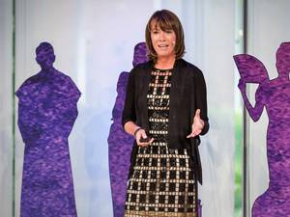14:02](https://www.ted.com/talks/janette_sadik_khan_new_york_s_streets_not_so_mean_any_more)

[Janette Sadik-Khan](https://www.ted.com/speakers/janette_sadik_khan) [New York's streets? Not so mean any more](https://www.ted.com/talks/janette_sadik_khan_new_york_s_streets_not_so_mean_any_more)

In this funny and thought-provoking talk, Janette Sadik-Khan, transportation commissioner of New York City, shares projects that have reshaped street life in the 5 boroughs, including pedestrian zones in Times Square, high-performance buses and a 6,000-cycle-strong bike share. Her mantra: Do bold experiments that are cheap to try out.

[Watch later](https://www.ted.com/session/new) · [137 comments](https://www.ted.com/talks/janette_sadik_khan_new_york_s_streets_not_so_mean_any_more)