Seminar 2

Linear methods for supervised classification with functional data

Functional data occurs when we observe curves or paths from a stochastic process X_{t .}
If for each curve or path we have a single response categorical variable Y, we have a classification problem. We assume here that all trajectories are observed continuously on a time interval [0;T] and that the variables X_{t} have zero mean.

- Fisher’s linear discriminant analysis with a functional predictor

Regression methods for functional data are easily generalized to binary classification, since Fisher’s linear discriminant function is equivalent to a multiple regression where the response variable Y is coded with 2 values a and b : most frequently ±1, but also conveniently with (p₀, p₁) the probability distribution of Y.
Costanzo D. et al. (2006) and Preda C. et al. (2007) have applied PLS functional classification to predict the quality of cookies from curves representing the resistance (density) of dough observed during the kneading process. For a given flour, the resistance of dough is recorded during the first 480 s of the kneading process. We have 115 curves which can be considered as sample paths of a L²-continuous stochastic process. Each curve is observed in 240 equispaced time points of the interval time [0, 480]. After kneading, the dough is processed to obtain cookies. For each flour we have the quality Y of cookies which can be Good, Adjustable and Bad. Our sample contains 50 observations for Y = Good, 25 for Y = Adjustable and 40 for Y = Bad . Due to measuring errors, each curve is smoothed using cubic B-spline functions with 16 knots.

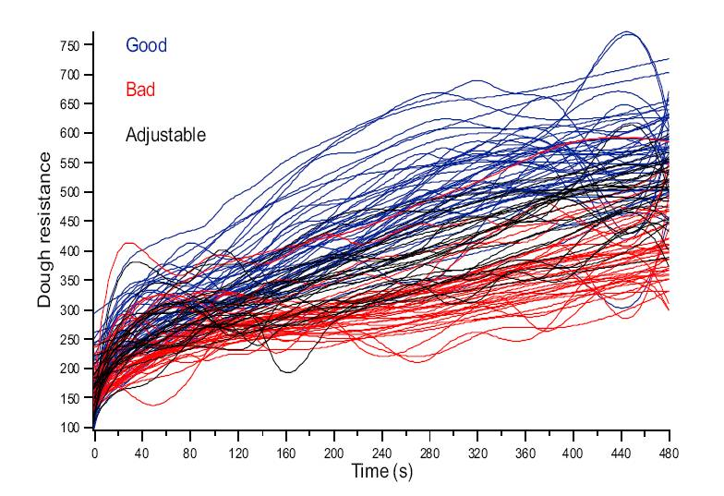  Figure 1 : Smoothed kneading curves | 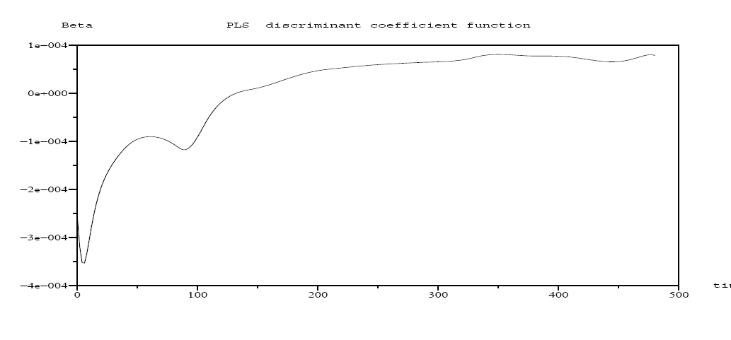  Figure 2 : Discriminant coefficient function

Some of these flours could be adjusted to become Good. Therefore, we have considered the set of Adjustable flours as the test sample and predict for each one the group membership, Y = {Good, Bad}, using the discriminant coefficient function (Fig. 2) given by the PLS approach on the 90 flours. PLS functional discriminant analysis gave an average error rate of 11% which is better than discrimination based on principal components.

- Functional logistic regression

Let Y be a binary random variable and $y_{1},…,y_{n}$ the corresponding random sample associated to the sample paths $x_{i}(t)$, $i=1,…\text{, }n$.
A natural extension of the logistic regression (Ramsay et al., 1997) is to define the functional logistic regression model by :

where $π_{i}=P(Y=1|X=x_{i}(t);t∈T)$.
It may be assumed (Ramsay et al., 1997) that the parameter function and the sample paths $x_{i}(t)$are in the same finite space:
$β(t)=\sum_{q=1}^{p}{b_{q}ψ_{q}(t)}=b^{'}ψ$
$$x_{i}(t)=\sum_{q=1}^{p}{c_{\text{iq}}ψ_{q}(t)}=c_{i}^{'}ψ$$
where $ψ_{1}(t),…,ψ_{q}(t)$are the elements of a basis of the finite dimensional space. Such an approximation transform the functional model (1) in a similar form to standard multiple logistic regression model whose design matrix is the matrix which contains the coefficients of the expansion of sample paths in terms of the basis, $C=(c_{\text{iq}})$, multiplied by the matrix $Φ=(φ_{\text{kq}}=\int_{T}{ψ_{k}(t)ψ_{q}(t)dt})$, whose elements are the inner product of the basis functions
with $b=(b_{1},…,b_{p})$, $π=(π_{1},…π_{p})$and $1$being the p-dimensional unity vector.
Finally, in order to estimate the parameters a further approximation by truncating the basis expansion could be considered. Alternatively, regularization or smoothing may be get by some roughness penalties approach.

In a similar way as we defined earlier functional PCR, Leng and Müller (2006) use functional logistic regression based on functional principal components with the aim of classifying gene expression curves into known gene groups.With the explicit aim to avoid multicollinarity and reduce dimensionality, Escabias et al. (2004) and Aguilera et al. (2006) propose an estimation procedure of functional logistic regression, based on taking as covariates a reduced set of functional principal components of the predictor sample curves, whose approximation is get in a finite space of no necessarily orthonormal functions. Two different forms of functional principal components analysis are then considered, and two different criterion for including the covariates in the model are also considered. Müller and Stadtmüller (2005) consider a functional quasi likelihood and an approximation of the predictor process with a truncated Karhunen-Loeve expansion. The latter also developed asymptotic distribution theory using functional principal scores.
Comparisons with functional LDA are in progress, but it is likely that the differences will be small.

- Anticipated prediction

In many real time applications like industrial process, it is of the highest interest to make anticipated predictions. Let denote d_{t} the approximation for a discriminant score considered on the interval time [0, t], with t < T. For functional PLS or logistic regression the score is but any method leading to an estimation of the posterior probability of belonging to one group gives a score. The objective here is to find t* < T such that the discriminant function d_{t}* performs quite as well as d_{T} .

For a binary target Y, the ROC curve and the AUC (Area Under Curve) are generally accepted as efficient measures of the discriminating power of a discriminant score. Let d_{t} (x) be the score value for some unit x. Given a threshold r, x is classified into Y = 1 if d_{t} (x) > r. The true positive rate or ”sensitivity” is P(d_{t} > r|Y = 1) and the false positive rate or 1−”specificity”, P(d_{t} > r|Y = 0). The ROC curve gives the true positive rate as a function of the false positive rate and is invariant under any monotonic increasing transformation of the score. In the case of an inefficient score, both conditional distributions of d_{t} given Y = 1 and Y= 0 are identical and the ROC curve is the diagonal line. In case of perfect discrimination, the ROC curve is confounded with the edges of the unit square.
The Area Under ROC Curve, is then a global measure of discrimination. It can be easily proved that AUC(t)= P(X₁ > X₀), where X₁ is a random variable distributed as d_{t} whenY= 1 and X₀ is independently distributed as d_{t} for Y = 0. Taking all pairs of observations, one in each group, AUC(t) is thus estimated by the percentage of concordant pairs (Wilcoxon-Mann-Whitney statistic).

A solution is to define t* as the first value of s where AUC(s) is not significantly different from AUC(T) Since AUC(s) and AUC(T) are two dependent random variables, we use a bootstrap test for comparing areas under ROC curves: we resample M times the data, according to a stratified scheme in order to keep invariant the number of observations of each group. Let AUC_{m}(s) and AUC_{m}(T) be the resampled values of AUC for m = 1 to M, and δ_{m} their difference. Testing if AUC(s) = AUC(T) is performed by using a paired t-test, or a Wilcoxon paired test, on the M values δ_{m}.

The previous methodology has been applied to the kneading data: the sample of 90 flours is randomly divided into a learning sample of size 60 and a test sample of size 30. In the test sample the two classes have the same number of observations. The functional PLS discriminant analysis gives, with the whole interval [0, 480], an average of the test error rate of about 0.112, for an average AUC(T) = 0.746. The anticipated prediction procedure gives for M = 50 and sample size test n = 30 (same number of observation in each class), t* = 186. Thus, one can reduce the recording period of the resistance of dough to less than half of the current one.

Works in progress comprises the extension of clusterwise functional regression to binary classification, comparison with functional logistic regression as well as “on-line” forecasting: instead of using the same anticipated decision time t* for all data, we will try to adapt t* to each new trajectory given its incoming measurements.

References

Aguilera A.M., Escabias, M. & Valderrama M.J. (2006) Using principal components for estimating logistic regression with high-dimensional multicollinear data, Computational Statistics & Data Analysis, 50, 1905-1924
Costanzo D., Preda C. & Saporta G. (2006) Anticipated prediction in discriminant analysis on functional data for binary response. In COMPSTAT2006, 821-828, Physica-Verlag
Escabias, M., Aguilera A.M. & Valderrama M.J. (2004) Principal Component Estimation of Functional Logistic Regression: discussion of two different approaches. Nonparametric Statistics 16, 365-384.
Leng X. & Müller, H.G. (2006) Classification using functional data analysis for temporal gene expression data. Bioinformatics 22, 68-76.
Preda C., Saporta G. & Lévéder C., (2007) PLS classification of functional data, Computational Statistics

