Analysis Document
McBSP

Fenix Project
Brazil-IP



Version : 1.1

Revision History
Date | Version | Description | Author
11/29/08 | 0.1 | Document construction | prga2
11/30/08 | 1.0 | Final review of all document | acv2,rgo,prga2
12/09/08 | 1.1 | Reference and document structure correction | hra, lvn, lgr2, mcrs

Table of Contents
1. Introduction 6
1.1 Document Overview 6
2. Use-case realizations 6
2.1 [UC 001] Receive 6
2.1.1 Analysis classes 6
2.1.2 Sequence diagram 8
2.2 [UC 004] Multichannel Transmit 8
2.2.1 Analysis classes 8
2.2.2 Sequence diagram 9
2.3 [UC 005] SPI Master Connect 10
2.3.1 Analysis classes 10
2.3.2 Sequence diagram 12
2.4 [UC 006] SPI Slave Connect 13
2.4.1 Analysis classes 13
2.4.2 Sequence diagram 15
2.5 [UC 016] Clock and Frame Synchronization Generation 15
2.5.1 Analysis classes 15
2.5.2 Sequence diagram 17
3. References 18

Figures
Figure 1. Receive Analysis Class diagram 7
Figure 2. Receive Sequence Diagram. 9
Figure 3. Transmit Multichannel Analysis Class diagram. 10
Figure 4. Transmit Multichannel Sequence Diagram. 12
Figure 5. SPI Master Analysis Class diagram. 13
Figure 6. SPI Master Sequence Diagram. 15
Figure 7. SPI Slave Refined Analysis Class diagram. 16
Figure 8. SPI Slave Sequence Diagram. 18
Figure 9. Clock and Frame Synchronization Generation Analysis Class 19
Figure 10. Clock and Frame Synchronization Generation sequence diagram 21

Tables
Table 1. Receive analysis class. 8
Table 2. Transmit Multichannel Analysis Class. 11
Table 3. SPI Master Analysis Class. 14
Table 4. SPI Slave Analysis Class. 17
Table 5. Clock and Frame Synchronization Generation Analysis Class. 20

- Introduction
This document contains the analysis project. Just some use cases are chosen to have the analysis made. They are choosing because of their complexity.
  - Document Overview
The following sections compose this document:
- Section 2 - Use-case realizations: this section describes and explains diagrams about the use-cases of the module;
- Section 3 – References: this section provides a complete list of all documents referenced elsewhere in this document.

- Use-case realizations

  - [UC 001] Receive
This use case describes the McBSP receive operation.
    - Analysis classes
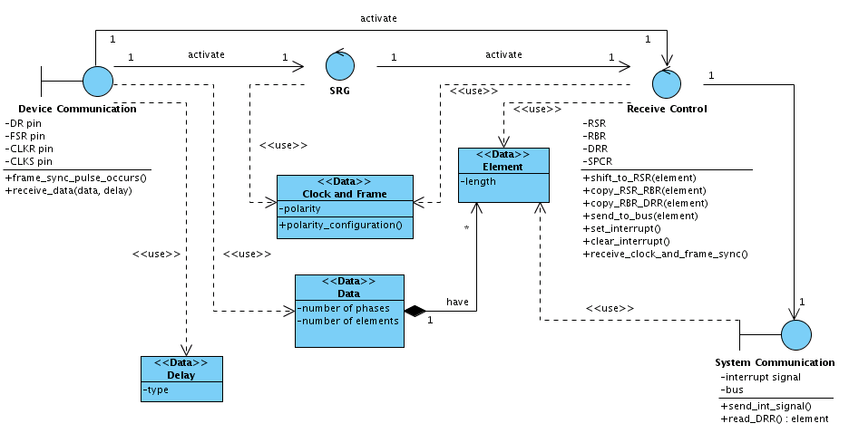
Figure 1. Receive Analysis Class diagram

Table 1. Receive analysis class.
Analysis classes | Description
Device Communication | The device communication stores all the information comes from the external device, it is the interface between the McBSP and the external device. It stores the signal come by DSR, FSR, CLKR and CLKS pins.  Two methods are used in this class the frame_sync_pulse_occurs() that indicates when the frame sync occurs, and the receive_data that represents the arrived of the data and the delay.
SRG | The SRG class is a representation of the McBSP Sample Rate Generate module that is another use case in the project. In this use case this class is responsible for generate clock and frame.
Receive Control | The Receive control is the mainly class from this use case, it stores the content of the registers RSR, RBR, DRR, SPCR need in the McBSP receive operation. This class makes the data flow inside the McBSP coping the data registers, from the arrive from the Device communication until the data arrives in the bus. With the correct frame and pulse generation, and controls the interruption send to the system.
System communication | This class provides the communication between the McBSP and the System. It stores all the information comes from the system, like: the reading interrupt signal and the bus data.
Clock and Frame | This class represents the clock and frame signal and their configuration. The polarity is stored in this class.
Data | This class represents the data processed by the McBSP, it stores the data itself and the data configuration, like the number of phases and the number of elements.
Element | This class represents each element that is used to compose the Data, the element length is stored too.
Delay | This class represents the data delay.

    - Sequence diagram
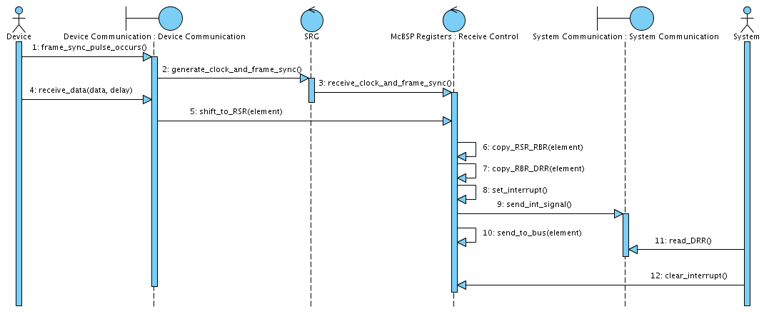
Figure 2. Receive Sequence Diagram.

First the Device communication class receives the frame sync pulse come from the sync pulse (frame sync pulse generated externally), after that the SRG class will generate the clock and frame sync; the receive control will receive the clock and frame. The data will arrive and it is stored in the Device Communication, the data is shifted to the RSR, element by element. So the data will follow the registers according with the control, the element inside the RSR will be copy to the RBR, and again copy to the DRR, now a interrupt signal will be send by the receive control to the System communication class. The system reads the DRR and clears the interruption inside the Receive Control.

  - [UC 004] Multichannel Transmit
This use case shows how the McBSP operates in the multichannel mode.
    - Analysis classes
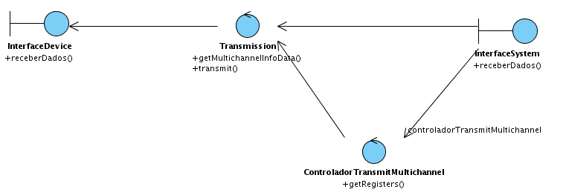
Figure 3. Transmit Multichannel Analysis Class diagram.

Table 2. Transmit Multichannel Analysis Class.
Analysis classes |  | Description
InterfaceDevice |  | This class is a boundary between the external device and the McBSP. It stores all the information need to the multichannel operation.
Transmission | This class represents the transmission use case. It will get the multichannel information data and transmit according with this configuration.
ControladorTransmitMultichannel |  | This class controls the multichannel operation. It will get the Multichannel configuration register verify and send control information to the Transmission module.
InterfaceSystem |  | This class is a boundary between the McBSP and the system. It provides all the data used in the McBSP to configure or data to be just sended.

    - Sequence diagram

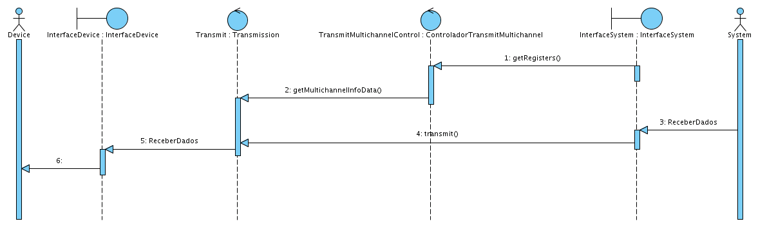
Figure 4. Transmit Multichannel Sequence Diagram.

The ControladorTransmitMultichannel class gets the multichannel configuration registers and verifies the registers of mask and partition, after that the transmission gets the multichannel configuration values and transmits in the multichannel mode according with the desired configuration.

  - [UC 005] SPI Master Connect
This use case shows how the McBSP works with the SPI protocol as a master device.
    - Analysis classes

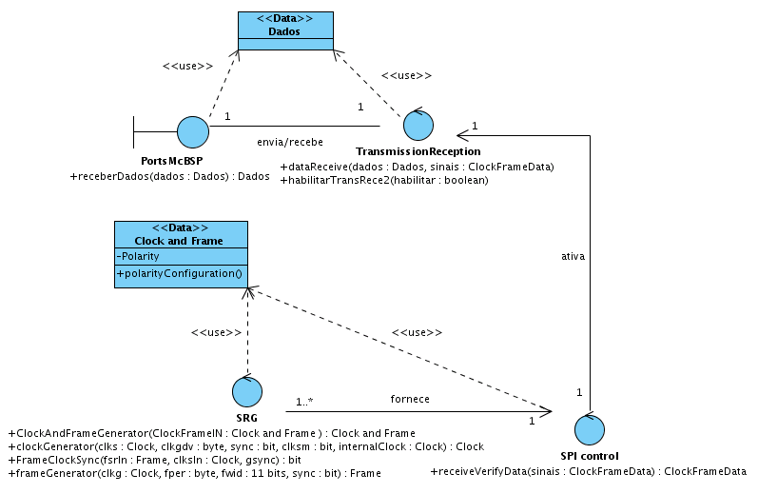
Figure 5. SPI Master Analysis Class diagram.

Table 3. SPI Master Analysis Class.
Analysis classes |  | Description
PortsMcBSP |  | This class is a boundary between the McBSP and the external device. It stores the data that will be transmitted/received by the McBSP.
TransmissionReception | This class is an abstraction of the McBSP transmission/reception modules that are described by use cases. It is responsible for make the transmission/reception operation, if they are enabled.
SPI control |  | This is the mainly class of this use case analysis, that is responsible to according with the McBSP configuration, control the transmission and reception operation.
SRG |  | This class represents the Sample Rate Generated module, described by its use case. It is responsible to generate clock and frame sync.
Dados |  | This class represents the data that will be transmitted/received by the McBSP.
Clock and Frame |  | This class represents the clock and frame configuration.

    - Sequence diagram
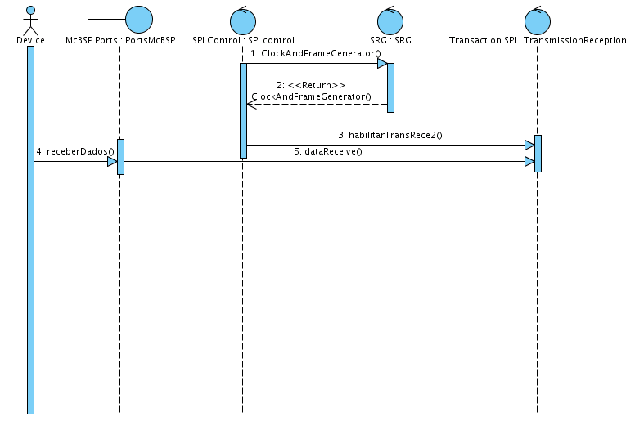
Figure 6. SPI Master Sequence Diagram.

The SRG gets the information from the SPI protocol that contains the Frame and Clock data to generated clock and frame, after that the TransmissionReception class verifies if the transmission reception is enabled. If it is, it makes the operation with the data, which are in the McBSP.

  - [UC 006] SPI Slave Connect
This use case shows how the McBSP works with the SPI protocol as a slave device.

    - Analysis classes

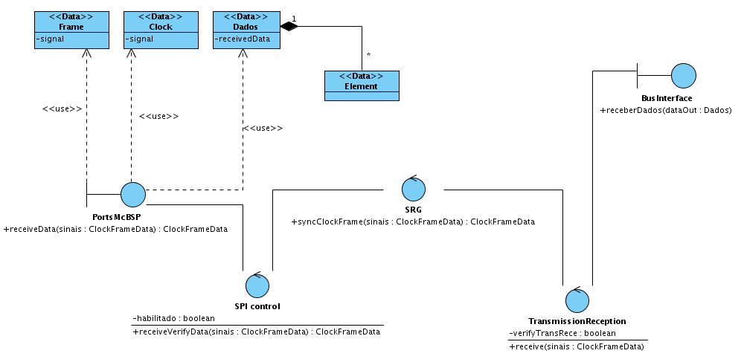
Figure 7. SPI Slave Refined Analysis Class diagram.

Table 4. SPI Slave Analysis Class.
Analysis classes |  | Description
PortsMcBSP |  | This class provides the communication between the McBSP internal classes and the external classes. It stores all the information come from the external device needed to the McBSP operates, like: Frame, Clock and Data information.
SPI Control | This is the mainly class of the use case analysis. It is responsible to, according with the information come from the PortsMcBSP, enable the McBSP operation.
SRG |  | This class represents the Sample Rate Generator that will synchronize the Clock and Frame.
TransmissionReception |  | This class represents is an abstraction of the transmission/reception operation in the McBSP that is used here, but is described in another use case. It makes the transmission/reception according with the SPI control verification.
BusInterface |  | This class represents the interface between the McBSP and the system made by the bus. It stores the data comes from the System.
Frame |  | This class represents the frame sync pulse with it signal.
Clock |  | This class represents the clock with it signal.
Dados |  | This class represents the data transmitted/received by the McBSP.
Element |  | This class is a basic entity of the Dados class,  The data is composed of one or more elements.

    - Sequence diagram
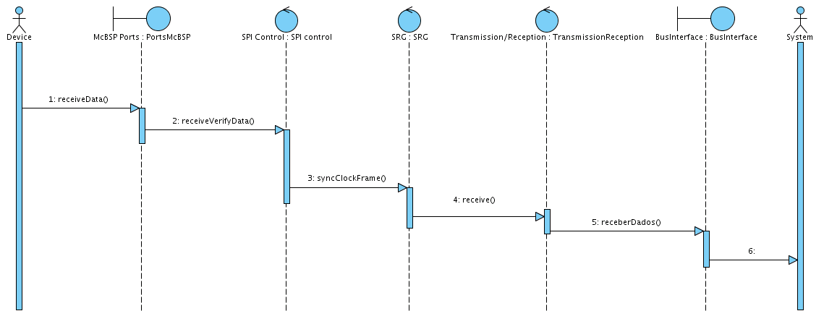
Figure 8. SPI Slave Sequence Diagram.

The data arrives in the PortsMcBSP from the Device. The SPI control verify the configuration data to enable the McBSP, if it is enable the SRG sync the clock and the frame and the reception/transmission occurs.

  - [UC 016] Clock and Frame Synchronization Generation
This use case show how is the generation of clock and frame inside the McBSP, using the Sample Rate Generator.
    - Analysis classes
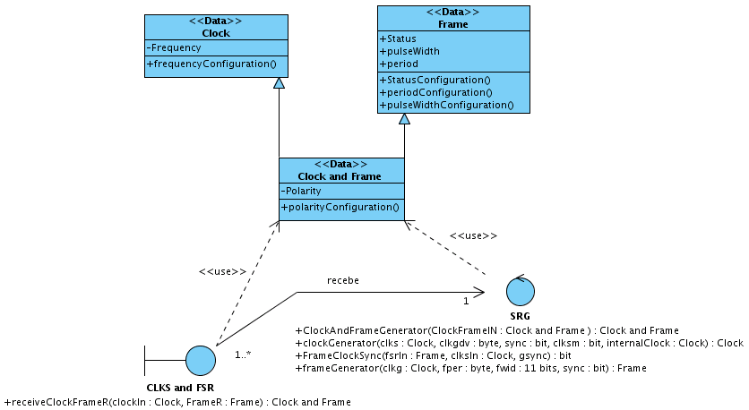
Figure 9. Clock and Frame Synchronization Generation Analysis Class

Table 5. Clock and Frame Synchronization Generation Analysis Class.
Analysis classes |  | Description
CLKS and FSR |  | This class is a boundary between the Device and the McBSP. It stores all the information needed to generate the clock and the frame. This information are: the clock information(frequency) and the frame information(status,pulse width,period).
SRG | This class is the mainly class of this use case, it will execute the operations to configure the clock and frame correctly. It stores the frame and clock information to manipulate them to generate the clock and frame according with the desired configuration.
Clock and Frame |  | This class represents the clock and the frame information used to configure the clock and frame configuration, the frame information is stored in a clock class and the Frame information is stored in a frame class.
Clock |  | This class represents the clock information. It stores the clock frequency.
Frame |  | This class represents the frame information. It stores all the frame information like: period, pulse width and status.

    - Sequence diagram
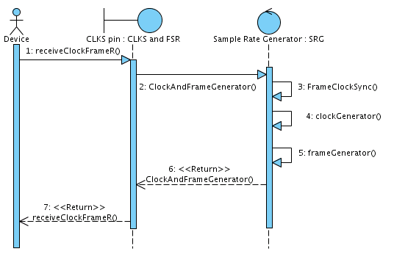
Figure 10. Clock and Frame Synchronization Generation sequence diagram

The Clock and Frame arrives in the CLKS and FSR class the SRG (Sample Rate Generator), gets the clock and frame information, synchronizes the Frame and Clock according with the information gotten, and generates the clock and the frame.

- References
  - McBSP Use Case Document: http://www.brazilip.org.br/fenix/projetos/ufpe-mcbsp/docs/brazilip_fenix_mcbsp_use_case_document.doc
  - McBSP Glossary Document: http://www.brazilip.org.br/fenix/projetos/ufpe-mcbsp/docs/brazilip_fenix_mcbsp_glossary_document.doc
  - TMS320C6000 DSP Multichannel Buffered Serial Port Reference Guide. December, 2006. Texas Instruments. Literature Number: SPRU580G.
  - TMS320C642x DSP Multichannel Buffered Serial Port Interface User’s Guide. September, 2007. Texas Instruments. Literature Number: SPRUEN2B.

