Architecture Document
McBSP

Project Fenix
Brazil-IP



Version : 1.3

Revision History
Date | Version | Description | Author
11/30/2008 | 1.0 | Inclusion of all views and explanations | acv2, hra, lvn, lgr2, mcrs, prga2
12/09/2008 | 1.1 | Reference corrections | hra, lvn, lgr2, mcrs
12/11/2008 | 1.2 | Inclusion of connections | hra, lgr2, lvn, mcrs
12/22/2008 | 1.3 | Views correction | hra, lgr2, lvn, mcrs, prga2
12/22/2008 | 1.4 | Process views corrections | acv2, mcrs

Table of Contents
1. Introduction 6
1.1 Document Overview 6
1.2 Definitions, Acronyms and Abbreviations 6
2. Architectural Representation 6
3. Use-Case View 7
4. Logical View 7
4.1 Architecturally Significant Layers 8
4.1.1 Communication 8
4.1.2 Data 8
4.1.3 Control 8
5. Process View 8
5.1 Receive 9
5.2 Transmit 9
5.3 Transmit Multichannel 10
5.4 Receive Multichannel 11
5.5 SPI Master Connect 12
5.6 SPI Slave Connect 12
5.7 Receive, Transmit and Sample Rate Generator Reset 13
5.8 Companding Internal Data 13
5.9 Using General Purpose 14
5.10 Frame Sync and Clock Operations 15
6. Component View 15
6.1 Connections 16
6.1.1 Device Connections 16
6.1.2 System Connections 17
6.1.3 Internal Connections 17
7. References 17

Table of Figures
Figure 1 McBSP Use Case Diagram 7
Figure 2 McBSP Logical View 8
Figure 3 Receive Process 9
Figure 4 Transmit Process 10
Figure 5 Transmit Multichannel Process 11
Figure 6 Receive Multichannel Process 12
Figure 7 SPI Master Process 13
Figure 8 SPI Slave Process 14
Figure 9 Reset Portions Process 15
Figure 10 Companding Internal Data Process 16
Figure 11 General Purpose Process 16
Figure 12 Frame Sync and Clock Operation Process 17
Figure 13 McBSP Component View 18

- Introduction
The purpose of this document is to describe the project architecture showing all the internal controllers that implements the module and the relationships between them. The architecture will be used in implementation phase like a directive to the developers.

  - Document Overview
The following sections compose this document:
- Section 2 - Architectural Representation: this section describes what module architecture is for the current system, and how it is represented.
- Section 3 - Use-Case View: explains the important use-cases of the actual architecture for the system;
- Section 4 - Logical View: show and describes system’s logic view;
- Section 5 - Process View: this section presents the descriptions of the tasks (process and threads) involved, their interactions and configurations;
- Section 6 - Component View: this section presents the components that form the system.
- Section 6.1 - Connections: this section provides a complete list of all documents referenced elsewhere in this document.

  - Definitions, Acronyms and Abbreviations

Term | Description
Companding | Refers to Compression and Expansion

- Architectural Representation
The architecture presented in this document represents the implementation of the following McBSP Controller: Transmission of data, Reception of data, SPI protocol, Clock and Frame Generation, General Purpose mode, Multichannel Transmission, Multichannel Reception and Companding data. The architecture is showed in different views, Use-Case view, Logical View and Process View. The Use-Case view presents through use case diagram the use cases and scenarios that encompasses architecturally significant behavior, classes, or technical risks; the Logical View shows through the capsules diagram, the organization of the capsules into layers; the Process View presents, using the capsules diagram, the descriptions of the tasks involved, their interactions and configurations.

- Use-Case View

This view shows the Use Case Diagram that represents the functionalities encompassed in the architecture.
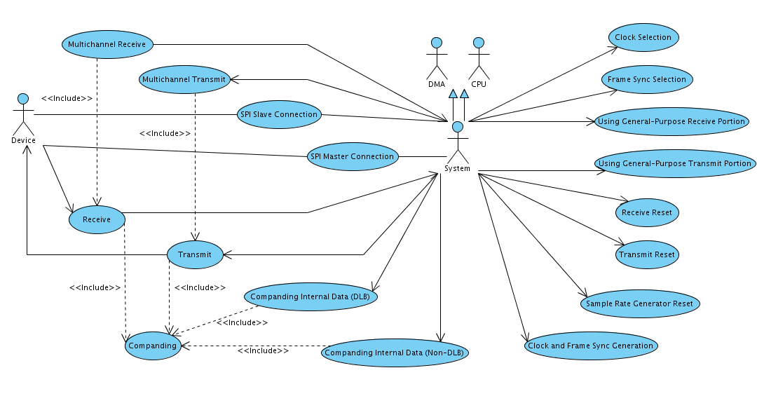
Figure 1 McBSP Use Case Diagram
- Logical View
In this section, the system classes are shown organized into three layers: Communication, Control and Data.
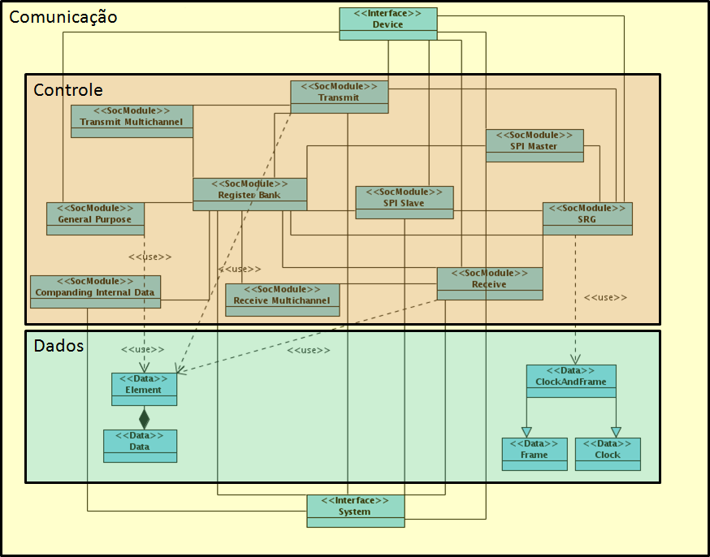
Figure 2 McBSP Logical View

  - Architecturally Significant Layers
The Communication, Data and Control Layers are described as showed below.

    - Communication
Communication layer is the layer responsible for the communication between the McBSP and the System and between the McBSP and the Device.

    - Data
Data layer is composed by the classes responsible for the storage of the data utilized in the McBSP processes.

    - Control
Control layer is responsible for all decisions made to realize the McBSP functionalities.
- Process View

The Process View shows the descriptions of the tasks (process and threads) involved in the execution of the each use case, their interactions and configurations.
  - Receive
This process realizes the following Use Cases:
[UC001] Receive
[UC017] Companding

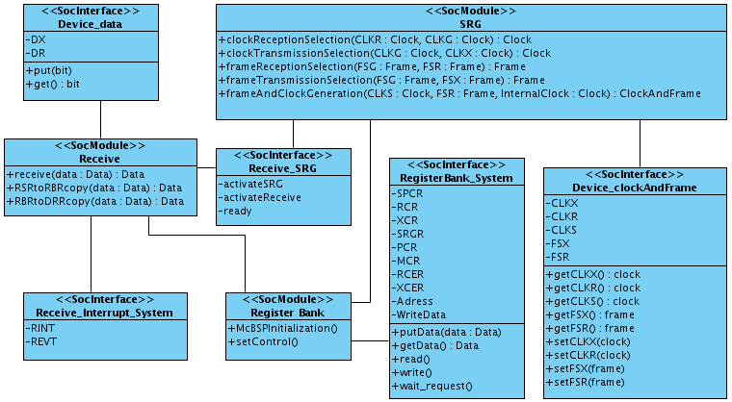
Figure 3 Receive Process

  - Transmit
This process realizes the following Use Cases:
[UC002] Transmit
[UC017] Companding

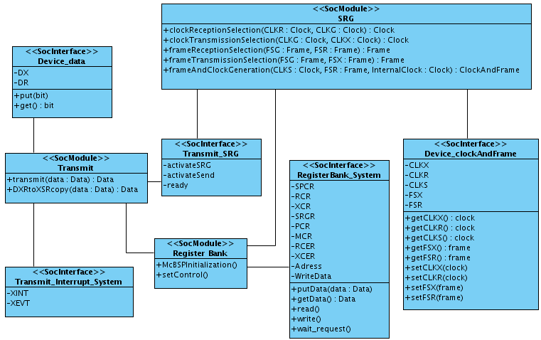
Figure 4 Transmit Process

  - Transmit Multichannel
This process realizes the following Use Case:
[UC003] Transmit Multichannel
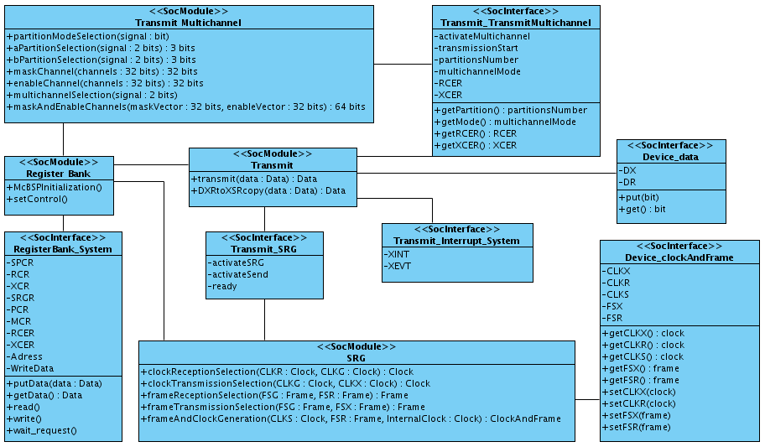
Figure 5 Transmit Multichannel Process

  - Receive Multichannel
This process realizes the following Use Case:
[UC004] Receive Multichannel
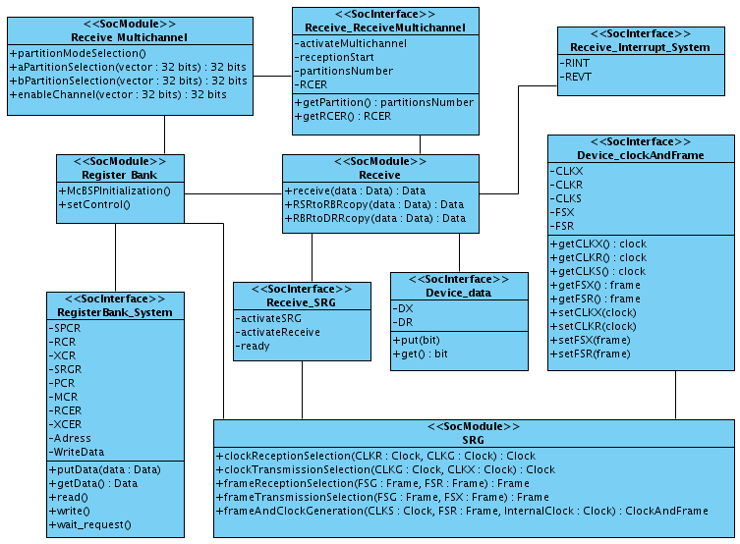
Figure 6 Receive Multichannel Process

  - SPI Master Connect
This process realizes the following Use Case:
[UC005] SPI Master Connect
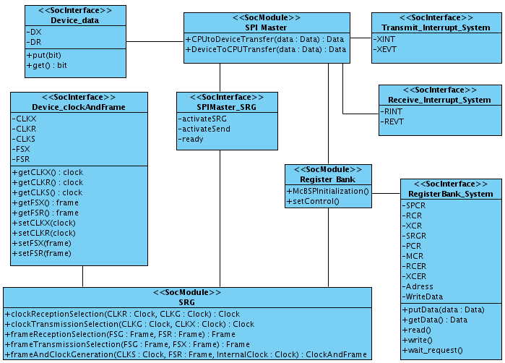
Figure 7 SPI Master Process

  - SPI Slave Connect
This process realizes the following Use Case:
[UC006] SPI Slave Connect
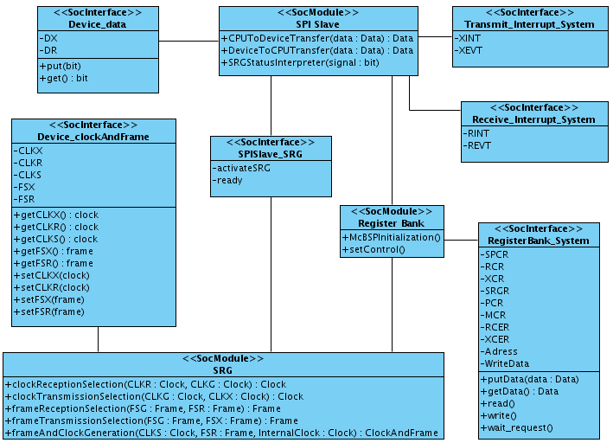
Figure 8 SPI Slave Process

  - Receive, Transmit and Sample Rate Generator Reset
This process realizes the following Use Case:
[UC007] Receive Reset
[UC008] Transmit Reset
[UC009] Sample Rate Generator
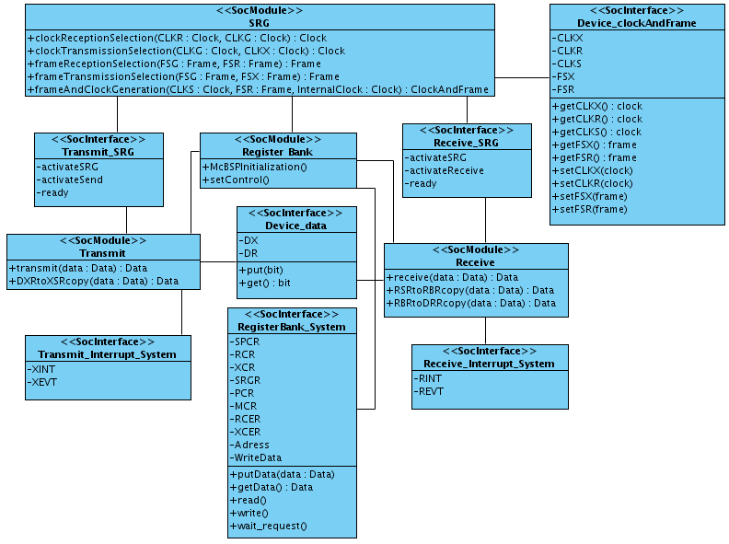
Figure 9 Reset Portions Process

  - Companding Internal Data
This process realizes the following Use Case:
[UC010] Companding Internal Data Using DLB
[UC011] Companding Internal Data Using non-DLB
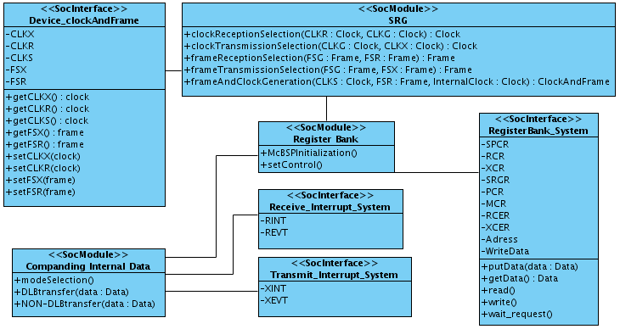
Figure 10 Companding Internal Data Process

  - Using General Purpose
This process realizes the following Use Case:
[UC012] Using General Purpose in Receive Portion
[UC013] Using General Purpose in Transmit Portion
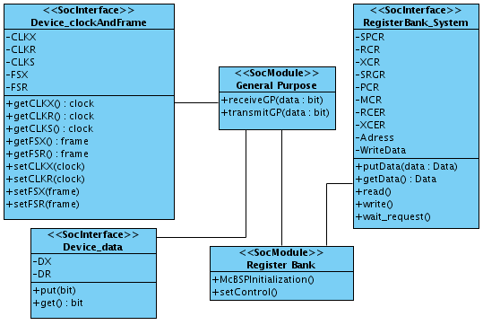
Figure 11 General Purpose Process

  - Frame Sync and Clock Operations
This process realizes the following Use Case:
[UC014] Frame Synchronization Source Selection
[UC015] Clock Source Selection
[UC016] Clock and Frame Synchronization Generation
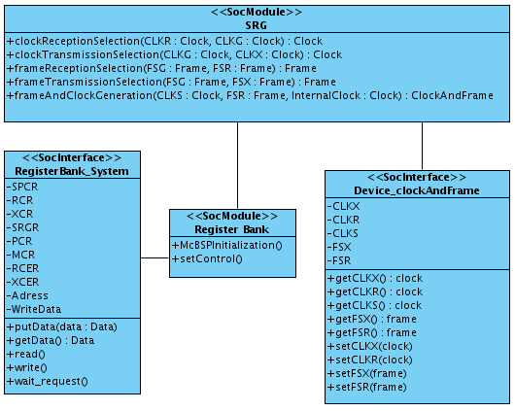
Figure 12 Frame Sync and Clock Operation Process
- Component View
The Component View shows all components and their connections.
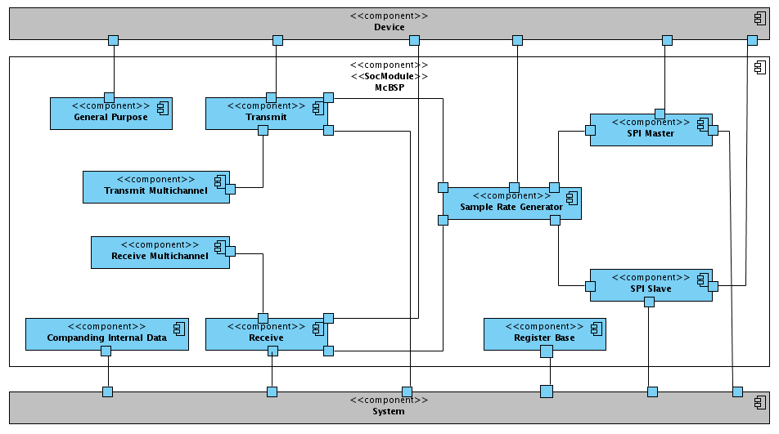
Figure 13 McBSP Component View
  - Connections
    - Device Connections
- General Purpose and Device – Their communication occurs by the transmission and reception of data between the Device and the McBSP. The data transmitted from the McBSP to the Device reflects the status of the stored data in the register base. When the data is sent by the Device to the McBSP (reception) the input data is held into the register base.
- Transmit and Device – The data sent by the System is passed by the Transmit portion to the Device. The clock and frame sync signals can be internal or external.
- Receive and Device – The data sent by the Device is passed by the Receive portion of McBSP to the System. The clock and frame sync signals can be internal or external.
- Sample Rate Generator and Device – The Device sends the clock and frame sync signals to the Sample Rate Generator to be synchronized or these signals are generated by the Sample Rate Generator and sent to the Device.
- SPI Master and Device – When the McBSP is set to be in SPI Master mode the clock and frame sync signals are generated internally. The transmission and reception are enabled/disabled by the presence or absence of the master clock and the data transfer is started when the frame sync pulse is sent.
- SPI Slave and Device – When the McBSP is set on SPI Slave mode the clock and frame sync signals are generated by the Device. The McBSP waits for the presence of clock and frame sync pulse to transfer data.
    - System Connections
- Companding Internal Data and System – When the System wants to compand data the McBSP is set on Companding Internal Data mode. The data is read from the bus by the McBSP, companded as desired and sent back to the System.
- Receive and System – The data sent by the Device is passed to the System, the McBSP sends an interrupt signal to the System when the data is ready to be read.
- Transmit and System – The data sent by the System is passed to the Device. The McBSP sends an interrupt signal to the System and reads the data from the bus.
- Register Base and System – The System can read or write on the control registers of the Register Base.
- SPI Master and System – The communication between the McBSP in SPI Master mode and the System happens like the Transmit and Receive connections with the System.
- SPI Slave and System - The communication between the McBSP in SPI Slave mode and the System happens like the Transmit and Receive connections with the System.
    - Internal Connections
- Transmit and Transmit Multichannel – When the McBSP is in Multichannel mode, the transmit configurations are set by the Transmit Multichannel control.
- Receive and Receive Multichannel – When the McBSP is in Multichannel mode, the receive configurations are set by the Receive Multichannel control.
- Transmit and Sample Rate Generator – When is needed, the Transmit configures the Sample Rate Generator to generate clock and frame sync signals. The Sample Rate Generator is also controlled by the Transmit to synchronize or send these signals.
- Receive and Sample Rate Generator - When is needed, the Receive configures the Sample Rate Generator to generate clock and frame sync signals. The Sample Rate Generator is also controlled by the Receive to synchronize or send these signals.
- SPI Master and Sample Rate Generator – The Sample Rate Generator is controlled by the SPI Master to generate clock and frame sync signals.
- SPI Slave and Sample Rate Generator – The Sample Rate Generator is controlled by the SPI Slave to synchronize the clock and frame sync signals received by the Device.
- Register Base internal connections – The Register Base are directly connected to all McBSP components.
- References

  - McBSP Analysis Document: http://www.brazilip.org.br/fenix/projetos/ufpe-mcbsp/docs/brazilip_fenix_mcbsp_analysis_document.doc
  - McBSP Use Case Document: http://www.brazilip.org.br/fenix/projetos/ufpe-mcbsp/docs/brazilip_fenix_mcbsp_use_case_document.doc
  - McBSP Glossary Document: http://www.brazilip.org.br/fenix/projetos/ufpe-mcbsp/docs/brazilip_fenix_mcbsp_glossary_document.doc
  - McBSP Requirements Document: http://www.brazilip.org.br/fenix/projetos/ufpe-mcbsp/docs/brazilip_fenix_mcbsp_requirements_document.doc
  - TMS320C6000 DSP Multichannel Buffered Serial Port Reference Guide. December, 2006. Texas Instruments. Literature Number: SPRU580G.
  - TMS320C642x DSP Multichannel Buffered Serial Port Interface User’s Guide. September, 2007. Texas Instruments. Literature Number: SPRUEN2B.
  - Ipprocess Guideline for Analysis and Architecture: http://www.lincs.org.br/ipprocess/?q=filemanager/active&fid=284

Appendix A
McBSP

Project Fenix
BrazilIP

Version : 1.0
