Design document
McBSP

Fenix Project
Brazil-IP



Version : 1.0

Revision History
Date | Version | Description | Author
01/15/2009 | 0.1 | Document construction | acv2,lgr2
01/16/2009 | 1.0 | Protocol corrections and document review | acv2, hra, lgr2, lvn, mcrs, prga2

Table of Contents
1. Introduction 6
1.1 Document Overview 6
1.2 Definitions, Acronyms and Abbreviations 6
2. Package diagrams 6
2.1 McBSP 7
2.1.1 Capsules Diagram 7
2.1.2 Main capsules 7
2.1.3 Protocols 18
3. References 28

Figures
Figure 1: McBSP Package 6
Figure 2: Capsules Diagram 7
Figure 3: Transmit capsule 7
Figure 4: Transmit state diagram 8
Figure 5: Receive capsule 8
Figure 6: Receive state diagram 8
Figure 7: SPI Master capsule 9
Figure 8: SPI Master state diagram 9
Figure 9: SPI Slave capsule 10
Figure 10: SPI Slave state diagram 11
Figure 11: Sample Rate Generator capsule 12
Figure 12: Saple Rate Generator state diagram 12
Figure 13: Transmit Multichannel capsule 12
Figure 14: Transmit Multichannel state diagram 13
Figure 15: Receive Multichannel capsule 13
Figure 16: Receive Multichannel state diagram 14
Figure 17: Register Bank capsule 14
Figure 18: Register Bank state diagram 16
Figure 19: Companding Internal Data capsule 16
Figure 20: Companding Internal Data state diagram 17
Figure 21: General Purpose capsule 17
Figure 22: General Purpose state diagram 18
Figure 23: Device Clock and Frame Protocol 19
Figure 24: Device Clock and Frame state diagram 20
Figure 25: Device Data protocol 20
Figure 26: Device Data state diagram 21
Figure 27: Receive interrupt system protocol 21
Figure 28: Receive interrupt system state diagram 22
Figure 29: Receive sample rate generator protocol 22
Figure 30: Receive sample rate generator state diagram 22
Figure 31: Receive Multichannel receive protocol 23
Figure 32: Receive Multichannel state diagram 23
Figure 33: Register bank system protocol 24
Figure 34: Register bank system state diagram 24
Figure 35: Sample rate generator SPI master protocol 25
Figure 36: Sample rate generator SPI master state diagram 25
Figure 37: Sample rate generator SPI slave protocol 25
Figure 38: Sample rate generator SPI slave state diagram 25
Figure 39: Transmit Interrupt System protocol 26
Figure 40: Transmit Interrupt System state diagram 26
Figure 41: Transmit sample rate generator protocol 26
Figure 42: Transmit sample rate generator state diagram 26
Figure 43: Transmit multichannel transmit protocol 27
Figure 44: Transmit multichannel transmit state diagram 27

- Introduction
The design document is used to guide the project development through the explanation of the capsules and its protocols, to have a better understanding of project artifacts.
  - Document Overview
This document is composed by the following sections:
- Section 2 – Package diagram this section describes and explains the packages that form the module, its capsules and its protocols.
- Section 3 – References: this section provides a complete list of all documents referenced elsewhere in this document.
  - Definitions, Acronyms and Abbreviations
This table is used for specify any terms used some times in this text.

Table 1: Definitions, Acronyms and Abbreviations.
Term | Description
CAP | Capsule
PROT | Protocol
SD | State diagram
- Package diagrams
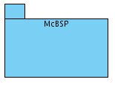
Figure 1: McBSP Package
  - McBSP
    - Capsules Diagram
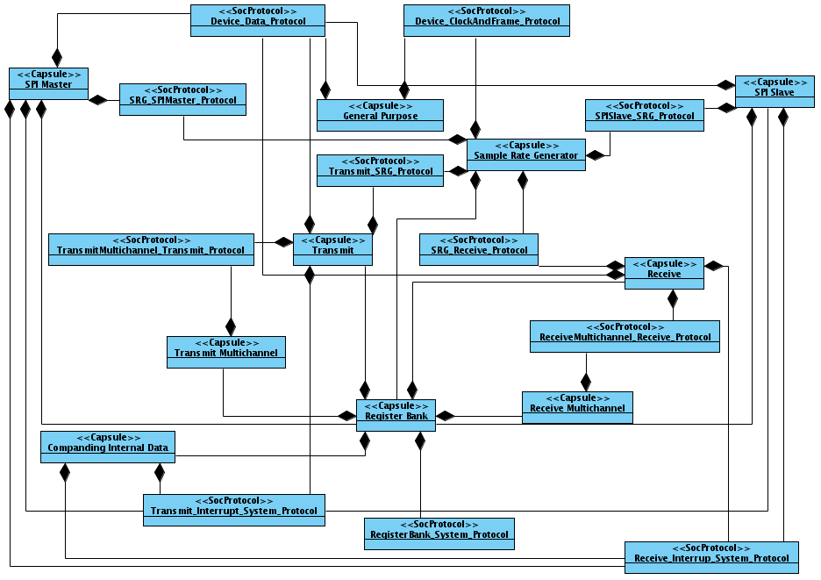
Figure 2: Capsules Diagram
    - Main capsules
- Transmit
The transmit capsule has two main methods. First, and most important, is the transmit method, that contains all the necessary aspects for a transmission, including the second method, that is a copy of data from DXR register to the XSR register.

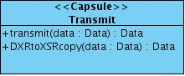
Figure 3: Transmit capsule

- Transmit state diagram
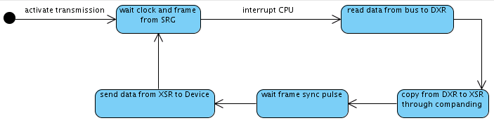
Figure 4: Transmit state diagram
When the transmission is activated, it waits for the clock and frame generated or synchronized by the Sample Rate Generator, after that, the McBSP interrupts the CPU or DMA and goes to the next state, the data is read from the bus and stored in DXR. From the DXR, the data is shifted to the XSR through the companding, in that state, the data can be compressed if desired. The next state waits for the frame sync pulse that can be external or internal. When the frame sync pulse occurs, the data is sent from XSR to Device through the DX port.

- Receive
Following the idea of the transmit capsule, the receive capsule has a main method, receive, that involves all the receive process, and includes the other two methods of the capsule, responsible for the internal copy between the registers.

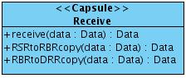
Figure 5: Receive capsule

- Receive state diagram
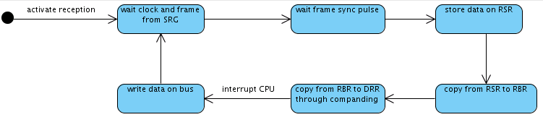
Figure 6: Receive state diagram
The first reception state after its activation is the wait clock and frame from SRG, in that state, the reception capsule waits from the SRG for the generation or synchronization of Clock and Frame. In the next state, when the frame sync pulse occurs, the reception of data begins and the data is stored on RSR. After that, a copy from RSR to RBR occurs followed by a copy from RBR to DRR through companding, where the data can be expanded as desired. Then, the McBSP interrupts the CPU or DMA and writes the data on bus.

- SPI Master
The SPI Master capsule has two methods responsible for the reception and transmission in SPI mode. CPUtoDeviceTransfer is a method equivalent to a transmission in a non SPI Mode, and sends the data according to the SPI protocol. Same as above, DeviceToCPUTransfer method receives the data from the device, according to the SPI protocol.

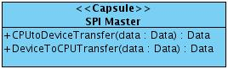
Figure 7: SPI Master capsule

- SPI Master state diagram
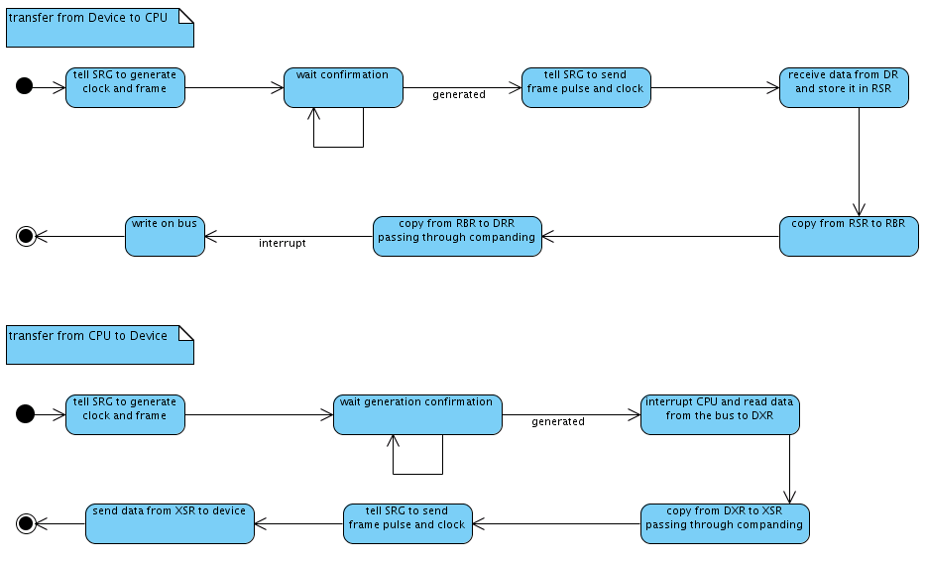
Figure 8: SPI Master state diagram
There are two independent state machines in this diagram: the first controls the transfer from Device to CPU and the second controls the transfer from CPU to Device.
In the initial state of the first state machine, the SRG will be warned to generate the clock and frame sync pulses. So, the SPI_Master goes to wait confirmation, and stays in this state until it receives the confirmation that the clock and frame sync pulses were generated. After the confirmation, the SPI_Master will warn the SRG to send the clock and frame sync pulses. So, in the next state, the SRG will receive data from DR and store it in RSR. In the next state, it will copy from RSR to RBR. After this, in the next state, it will copy from RBR to DRR (passing through companding) and finally, the SPI_Master sends an interrupt signal and write the data on bus.
In the initial state of the second state machine, the SRG will be warned to generate clock and frame sync pulses. So, the SPI_Master goes to wait confirmation, and stays until it receives the confirmation that the clock and frame sync pulses were generated. In the next state, the SPI_Master interrupts the CPU and it reads data from the bus to DXR. After this, in the next state, it will copy from DXR to XSR (passing through companding). Now, the SPI_Master will warn the SRG to send the frame and clock sync pulses and finally, in the next state, the SPI_Master will shift out the data from XSR to device.

- SPI Slave
The SPI Slave capsule is dependent of a method, SRGStatusInterpreter that verify if it is possible to receive (DeviceToCPUTransfer) or transmit (CPUToDeviceTransfer) in a SPI protocol, i.e., the other methods are only enabled when the status is received.

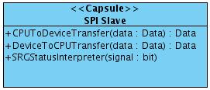
Figure 9: SPI Slave capsule

- SPI Slave state diagram
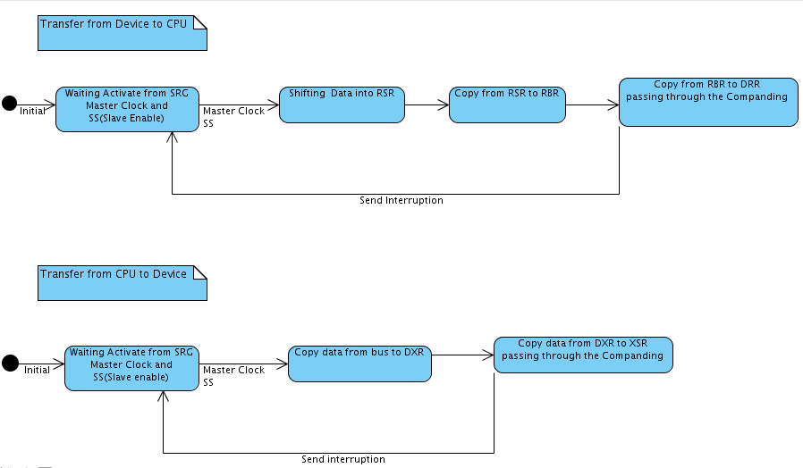
Figure 10: SPI Slave state diagram
There are two independent state machines in this diagram: the first controls the transfer from Device to CPU and the second controls the transfer from CPU to Device.
In the initial state of the first state machine, the SPI_Slave will wait the activation from the SRG to receive the Master Clock and the SS (Slave Enable), the SPI_Slave stays in this state until it to receive the activate. After the activation, the SPI_Slave will shift data from DR into RSR. In the next state, it will copy from RSR to RBR. After this, in the next state, it will copy from RBR to DRR (passing through companding) and it sends an interrupt signal.
In the initial state of the second state machine, the SPI_Slave will wait the activation from the SRG to receive the Master Clock and the SS (Slave Enable), it stays until it to receive the activate. In the next state, the SPI_Slave copies data from the bus to DXR. After this, in the next state, it will copy from DXR to XSR (passing through companding) and it sends an interrupt signal.

- Sample Rate Generator
The Sample Rate Generator capsule has 4 methods of selection. These methods verify the register configuration to choose the input values of the transmission/reception clock and frame. After that, the method frameAndClockGeneration is used to generate clock and frame.

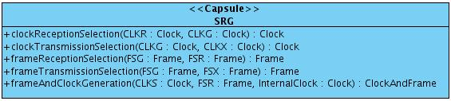
Figure 11: Sample Rate Generator capsule

- Sample Rate Generator state diagram
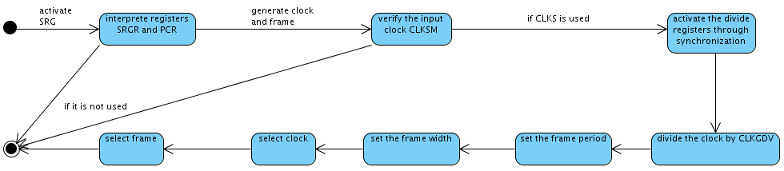
Figure 12: Saple Rate Generator state diagram
After the Sample Rate Generator is activated, it interprets the registers SRGR and PCR to get the necessary information to configure the module. The next step, the clock and frame are generated, and a verification of the input clock (CLKSM) is done. If it is not used, the FSM goes to the final state, but if it is used, and CLKS is also used, the next state is the one responsible for activate the clock division and frame division registers by the signals CLKS, GSYNC and FSR. After that, the clock is divided by the value in CLKGDV, the frame period is set, the frame width is set, the clock is selected, the frame is selected and then the FSM goes to the final state.

- Transmit Multichannel
The Transmit Multichannel capsule is formed by seven methods, and each one of these methods is responsible for one step of the multichannel transmission. Selection of the partition mode, selection of the content of partition A and B, the masked channels, the enabled channels, the multichannel selection and the masked and enabled channels.

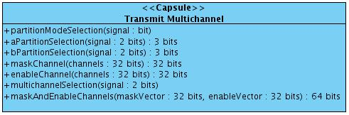
Figure 13: Transmit Multichannel capsule

- Transmit Multichannel state diagram
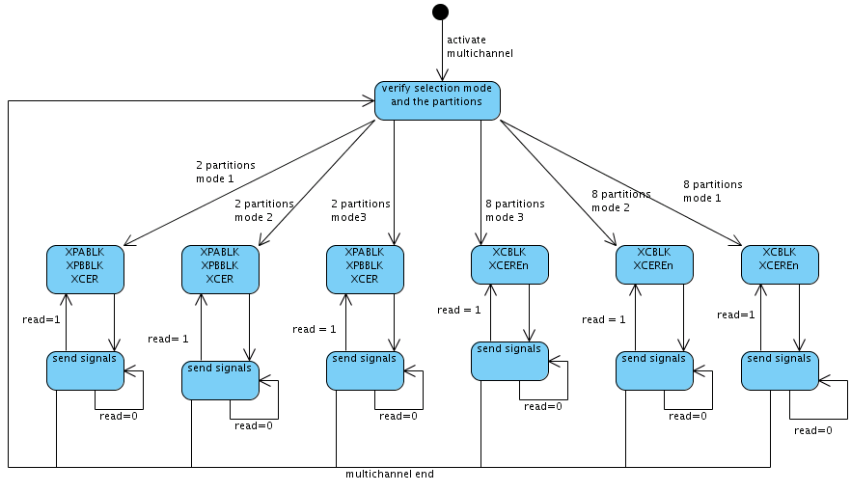
Figure 14: Transmit Multichannel state diagram
When the multichannel is activated, the first state is the verification of the selection mode and the number of partitions. After the module reads the registers according to the configuration set, it sends the content of the desired registers to the Transmit module. If the Transmit has already read the registers information the signal “read” is set and the Transmit multichannel module goes back to read the registers again to get their new configuration. If the Transmit hasn't read the registers information yet, the Transmit Multichannel module waits the reading of the Transmit to read the registers again. If the Transmit Multichannel is deactivated, it starts again from the initial state.

- Receive Multichannel
The Receive Multichannel capsule is a set of methods to configure the reception with the multichannel mode. The methods are the selection of the partition mode, selection of the content of partition A and B and the selection of the enable channels.

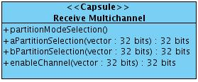
Figure 15: Receive Multichannel capsule

- Receive Multichannel state diagram
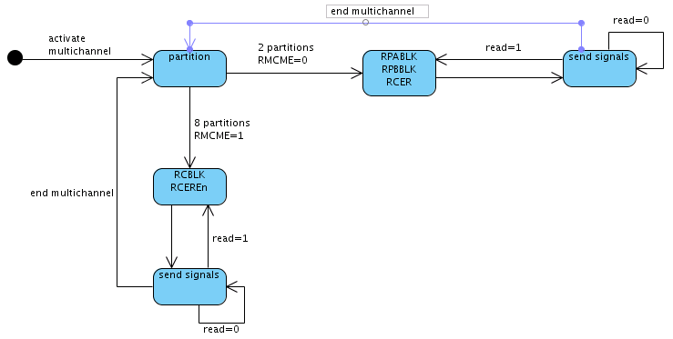
Figure 16: Receive Multichannel state diagram
When the Receive Multichannel is activated, the first state checks the number of partitions. After that, if 2 partitions mode is set, the module is going to read the RPABLK, RPBBLK and RCER, configuration registers of 2 partitions multichannel. If 8 partitions mode is selected, the module is going to read RCBLK and RCEREn. Then it sends the registers information to the Receive module. If the Receive has already read the registers information the signal “read” is set and the Receive Multichannel must read the registers again, sending the new configuration. If the Receive hasn't read the register information yet, the Receive multichannel must wait until the reading occurs. Finally, if the Receive Multichannel is deactivated, the machine state waits the activation and starts from the initial state.

- Register Bank
The methods of the Register Bank capsule are responsible of starting the McBSP. The McBSPInitialization initializes the whole McBSP. After that, all the controls of the port are set by the method setControl.

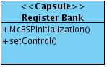
Figure 17: Register Bank capsule

- Register Bank state diagram
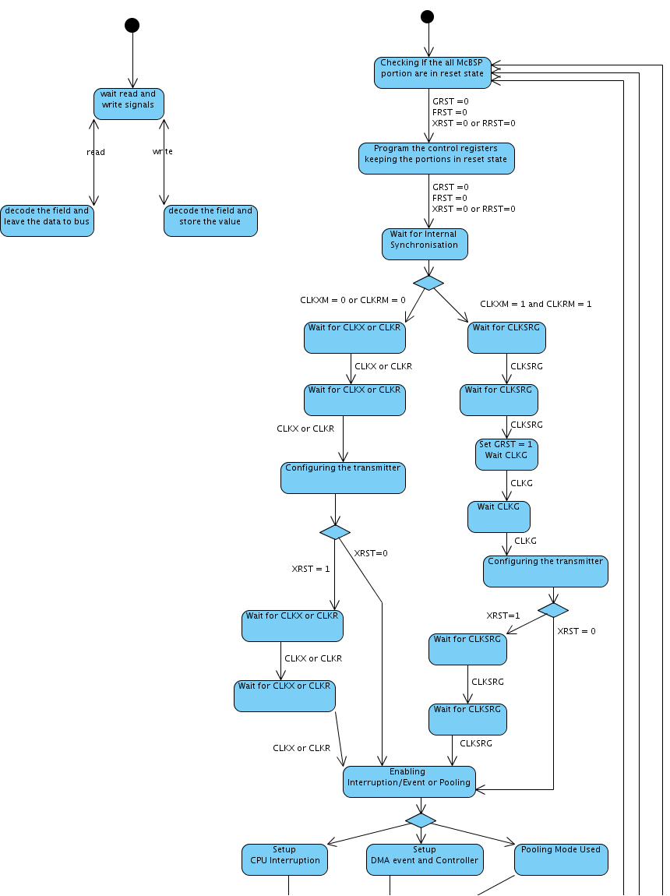
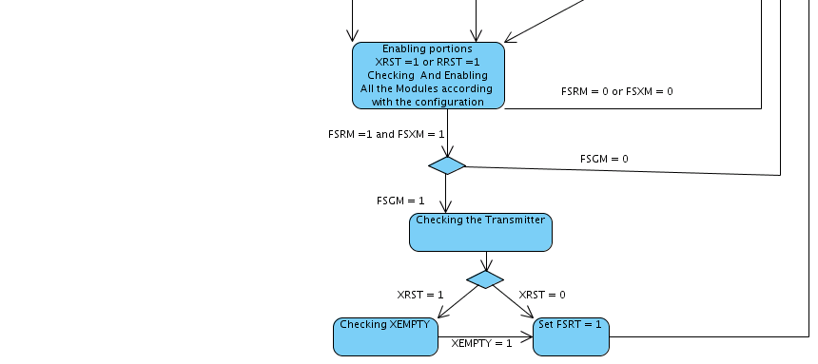
Figure 18: Register Bank state diagram
The registers in the Register Bank can be accessed and edited by the System at the initialization or during the McBSP operation (only the dynamical registers). The state machines on the right and left represents them, respectively.
The left state machine is simple and its first state waits for a read or write signal. If there is a read operation, the next state decodes the field and leaves the data to bus. In case of a write operation, the next state decodes the field and stores the value on the correct register.
The right state machine is responsible for the McBSP initialization. It verifies if all the portions are in the reset state and, if so, it starts to configure the registers in the Register Bank. It is here where the clock and frame, interruptions and exceptions settings are configured.

- Companding Internal Data
The Companding Internal Data has the main method, modeSelection, which checks the current configuration, and compresses and expands through the NON-DLBTransfer method, or the DLBTransfer method.

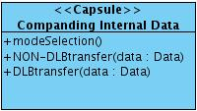
Figure 19: Companding Internal Data capsule

- Companding Internal Data state diagram
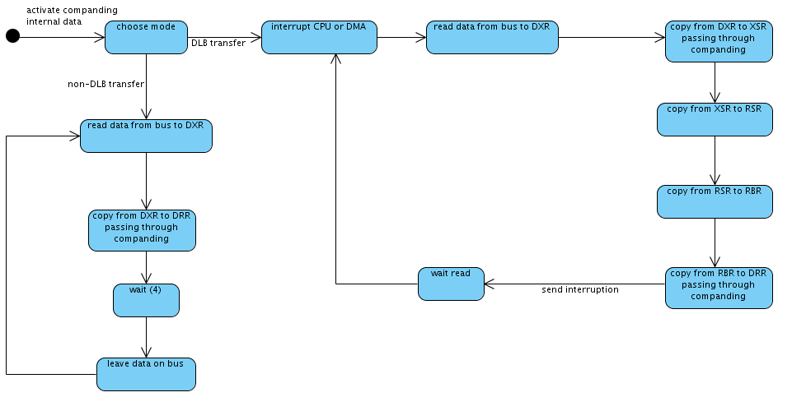
Figure 20: Companding Internal Data state diagram
In the initial state, the Companding Internal Data will choose the transfer mode, which can be DLB transfer or non-DLB transfer.
If the chosen mode is DLB transfer, then, in the next state, the Companding Internal Data will interrupt the CPU or DMA. So, in the next state, it reads data from bus to DXR. After this state, it will copy from DXR to XSR, passing through the companding hardware. After this, in the next state, it will copy from XSR to RSR. After, in the next state, it will copy from RSR to RBR. After this, in the next state, it will copy from RBR to DRR, passing through the companding hardware. So, in the next state, it waits that the CPU or DMA reads the data. After read, the Companding Internal Data returns to state where it interrupts the CPU or DMA.
However, if the chosen mode is non-DLB transfer, then in the next state the Companding Internal Data reads data from bus to DXR. After this state, it will copy from DXR to DRR, passing through companding hardware. After, in the next state, it waits four clock cycles. So, in the next state, it leaves the data on bus. After this, the Companding Internal Data returns to state where it reads data from bus to DXR.

- General Purpose
The General Purpose has two methods: the receiveGP is responsible for the reception ports: CLKR and FSR, depending of the CLKRM and FSRM configuration, these ports can be set as output or input. The transmitGP is responsible for the transmission ports: CLKX and FSX.

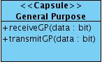
Figure 21: General Purpose capsule

- General Purpose state diagram
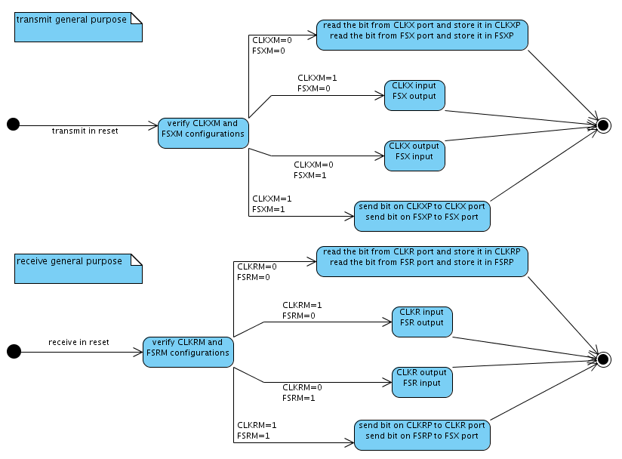
Figure 22: General Purpose state diagram
The Capsule General Purpose has two State Diagrams, one for transmission and one for reception. To activate the general purpose transmission, the McBSP transmit portion must be in reset state, in that case, occurs a verification of CLKXM and FSXM configurations. If CLKXM = 0 and FSXM = 0, both ports CLKX and FSX are inputs and read, where their values are stored in CLKXP and FSXP. If CLKXM = 1 and FSXM = 0, CLKX is set input and FSX output. If CLKXM = 0 and FSXM = 1, CLKX is set output and FSX input. If CLKXM = 1 and FSXM = 1, both CLKX and FSX are set output and the bits stored in CLKXP and FSXP are sent through them. The DX port always actuates as an output and its value is driven by the DX_STAT field.
The general purpose reception occurs as the transmission, but the configuration affects the CLKR and FSR ports and the CLXP and FSXP fields. The CLKS and DR ports are always inputs and their values are stored in the DR_STAT and CLKS_STAT fields, respectively.

    - Protocols
- Device Clock and Frame

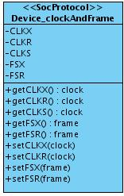
Figure 23: Device Clock and Frame Protocol
- CLKX: Clock synchronization pulse for transmission
- CLKR: Clock synchronization pulse for reception
- CLKS: External clock source
- FSX: Frame synchronization pulse for transmission
- FSR: Frame synchronization pulse for reception

- Device Clock and Frame state diagram
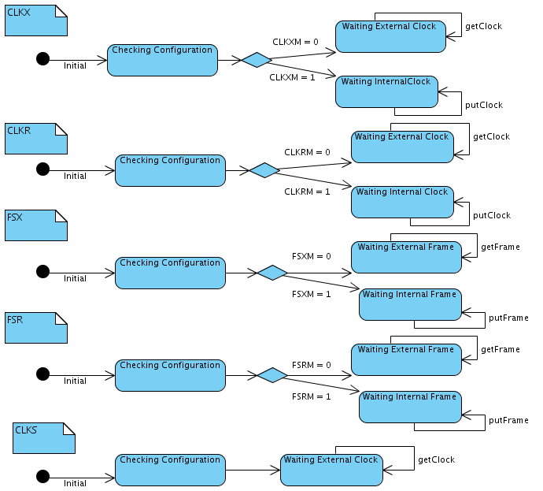
Figure 24: Device Clock and Frame state diagram
For the clock and frame ports (CLKX, CLKR, FSX and FSR, that can be inputs or outputs), a configuration field must be checked. For each, if the field analyzed (CLKXM, CLKRM, FSXM and FSRM, respectively) is cleared, the port is an input and the clock or frame must be driven by the external source; else (if the field is set), the port is an output and the pin receives the clock or frame coming from the Sample Rate Generator. As the CLKS port is always an input, there is no decision to make and the clock is received from the external source.

- Device data
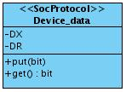
Figure 25: Device Data protocol
- DX: Signal responsible for free the data in the DX pin.
- DR: Signal responsible for warn the DR pin to receive data.

- Device Data state diagram
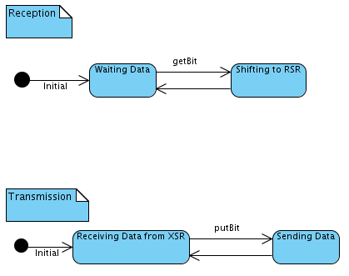
Figure 26: Device Data state diagram
Here, there are two protocol state machines: one for the reception and one for the transmission.
In the reception one, the first state waits for the data to come from the Device, through the DR port. Once it has arrived, the next state gets the bit and shifts it to RSR, returning again to the previous state, to wait for the next bit, until the whole data is transferred.
In the transmission state machine, the first state receives the data coming from XSR and goes to the next state, where the first bit is passed to the Device through DX port. The FSM returns then to the previous state and send the next bit of the data receive previously, until the whole data is transferred.

- Receive interrupt system
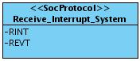
Figure 27: Receive interrupt system protocol
- RINT: Signal that warns the CPU that an interruption happened in a reception.
- REVT: Signal that warns the DMA that an event happened in a reception.

- Receive interrupt system state diagram
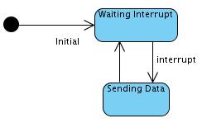
Figure 28: Receive interrupt system state diagram
In this very simple state machine, the first state waits the interrupt sign and interrupts the System (CPU or DMA), sending a RINT or REVT signal. In the next state, data will be sent to the System. At the end of this transfer, the FSM returns to the first state.

- Receive sample rate generator
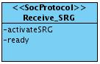
Figure 29: Receive sample rate generator protocol

- activateSRG: Signal responsible for activate the Sample Rate Generator to receive clock and frame.
- ready: Signal that warns the presence of the generated clock and frame by the sample rate generator, and they are ready for use.

- Receive sample rate generator state diagram
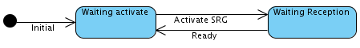
Figure 30: Receive sample rate generator state diagram
The first state waits a signal to activate the Sample Rate Generator. The next state waits the clock and frame generation and then sends a ready signal warn this generation.

- Receive Multichannel receive
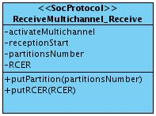
Figure 31: Receive Multichannel receive protocol
- activateMultichannel: Signal responsible for activate the multichannel
- receptionStart: Signal to warn the receive multichannel to reconfigure the registers
- partitionNumber: Signal that represents the number of partitions involved in the receive multichannel
- RCER: Vector that is the copy of the Receive channel enable register, used to disable or enable the corresponding channel

- Receive Multichannel state diagram
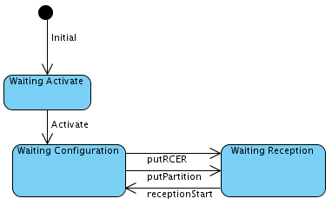
Figure 32: Receive Multichannel state diagram
The first state waits the multichannel activation and then goes to the waiting configuration state. The multichannel fields on the Register Bank will be read and the enabled/unmasked channels and number of partitions will be sent. The next state waits for a receptionStart signal to reanalyze the previous fields, returning to the previous state.

- Register bank system
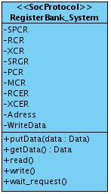
Figure 33: Register bank system protocol
- SPCR: content of the SPCR register
- RCR: content of the RCR register
- XCR: content of the XCR register
- SRGR: content of the SRGR register
- PCR: content of the PCR register
- MCR: content of the MCR register
- RCER: content of the RCER register
- XCER: content of the XCER register
- Address: vector that informs what register will receive the data
- WriteData: signal that activates the writing in the Register Bank

- Register bank system state diagram

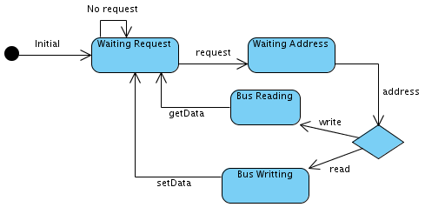
Figure 34: Register bank system state diagram
In the first state, the FSM waits for a request. When it comes, it goes to the next state to receive the operation address and a read or write signal. If it is a write operation, the bus is read and the register corresponding to the address received is updated. If it is a read operation, the register is read and this value is sent to bus.

- Sample rate generator SPI master
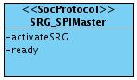
Figure 35: Sample rate generator SPI master protocol
- activateSRG: Signal responsible for activate the Sample Rate Generator to receive clock and frame.
- ready: Signal that warns the presence of the generated clock and frame by the sample rate generator, and they are ready for use.

- Sample rate generator SPI master state diagram
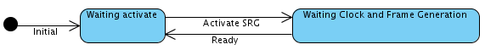
Figure 36: Sample rate generator SPI master state diagram
This state machine is identical to the Receive Sample Rate Generator state machine, described in the SD0014 section.

- Sample rate generator SPI slave
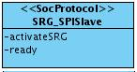
Figure 37: Sample rate generator SPI slave protocol
- activateSRG: Signal responsible for activate the Sample Rate Generator to receive clock and frame.
- ready: Signal that warns the presence of the generated clock and frame by the sample rate generator, and they are ready for use.

- Sample rate generator SPI slave state diagram
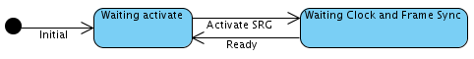
Figure 38: Sample rate generator SPI slave state diagram
This state machine is identical to the Receive Sample Rate Generator state machine, described in the SD0014 section.

- Transmit Interrupt System
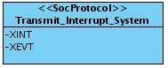
Figure 39: Transmit Interrupt System protocol
- XINT: Signal that warns the CPU that an interruption happened in a transmission.
- XEVT: Signal that warns the DMA that an event happened in a transmission.

- Transmit Interrupt System state diagram
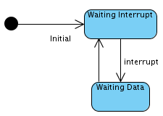
Figure 40: Transmit Interrupt System state diagram
Similarly to the Receive Interrupt System state machine, the first state waits the interrupt sign and interrupts the System (CPU or DMA), sending a RINT or REVT signal. The main difference is that in the next state, the data will be received from the System. When the data transfer is finished, the FSM returns to the first state.

- Transmit sample rate generator
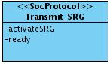
Figure 41: Transmit sample rate generator protocol
- activateSRG: Signal responsible for activate the Sample Rate Generator to receive clock and frame.
- ready: Signal that warns the presence of the generated clock and frame by the sample rate generator, and they are ready for use.

- Transmit sample rate generator state diagram
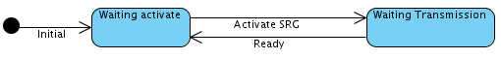
Figure 42: Transmit sample rate generator state diagram
This state machine is identical to the Receive Sample Rate Generator state machine, described in the SD0014 section.

- Transmit multichannel transmit
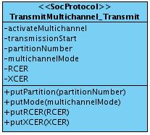
Figure 43: Transmit multichannel transmit protocol
- activateMultichannel: Signal responsible for activate the multichannel
- transmissionStart: Signal for warn the the transmit multichannel to reconfigure the registers
- partitionNumber: Signal that represents the number of partitions involved in the receive multichannel
- multichannelMode: Vector that represents one of the three possible modes of the transmit multichannel
- RCER: Vector that is the copy of the Receive channel enable register, used to disable or enable the corresponding received channel
- XCER: Vector that is the copy of the transmit channel enable register, used to disable or enable the corresponding transmitted channel
- Transmit multichannel transmit state diagram

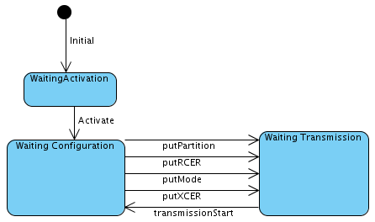
Figure 44: Transmit multichannel transmit state diagram
The first state waits the multichannel activation. After that, the multichannel registers are analyzed and the multichannel mode, the number of partitions and the enabled/unmasked channels are sent. The next state waits for a transmissionStart signal to return to the previous state and reanalyze the multichannel configurations.

- References
  - McBSP Use Case Document: http://www.brazilip.org.br/fenix/projetos/ufpe-mcbsp/docs/brazilip_fenix_mcbsp_use_case_document.doc
  - McBSP Glossary Document: http://www.brazilip.org.br/fenix/projetos/ufpe-mcbsp/docs/brazilip_fenix_mcbsp_glossary_document.doc
  - TMS320C6000 DSP Multichannel Buffered Serial Port Reference Guide. December, 2006. Texas Instruments. Literature Number: SPRU580G.
  - TMS320C642x DSP Multichannel Buffered Serial Port Interface User’s Guide. September, 2007. Texas Instruments. Literature Number: SPRUEN2B.
  - Ipprocess Guideline for Analysis and Architecture: http://www.lincs.org.br/ipprocess/?q=filemanager/active&fid=284

